Moduldokumentation

Modul Verteilte Systeme (vesys)

Simon Wächter

2017

Inhalt

1 Einleitung 5

1.1 Einleitung 5

1.2 Lernziele 5

1.3 Prüfungen 5

2 Woche 1 6

2.1 Definition of Distributed Systems 6

2.1.1 Definitions 6

2.1.2 Classification 6

2.1.3 Pros and Cons 7

2.1.4 Interaction Models 7

2.1.5 Client/Server Model 8

2.1.6 Communication Models 8

2.1.7 Communication Styles 9

2.2 Challenges of Distributed Systems 10

2.2.1 Heterogeneity 10

2.2.2 Latency 10

2.2.3 Security 10

2.2.4 Scalability 11

2.2.5 Failures 11

2.2.6 Concurrency 12

2.2.7 Consistency 12

2.3 Networking 12

2.3.1 Protocol & Network Levels 12

2.3.2 IP Socket Connections 13

2.3.3 IP Addressing 13

2.3.4 TCP/UDP Common Port Numbers 14

2.3.5 InetAddress 14

2.3.6 Network Interfaces 15

2.4 Sockets 15

2.4.1 Sockets 15

2.4.2 TCP Sockets 16

2.4.3 Java Socket 16

2.4.4 Sample Client (Echo) 18

2.4.5 Sample Client (Mailer) 18

2.4.6 ServerSocket 19

2.4.7 Echo Server 20

2.4.8 Concurrent Echo Server 20

2.4.9 Concurrent Echo Server (Threaded) 20

2.4.10 Concurrent Echo Server (Limitierter Threadpool) 21

2.4.11 Concurrent Echo Server (Dynamischer Threadpool) 22

3 Woche 2 24

3.1 Input and Output Streams 24

3.1.1 OutputStream 24

3.1.2 InputStream 24

3.2 Filter Streams 25

3.2.1 FilterOutputStream 25

3.2.2 DataOutputStream 26

3.2.3 DataOutputStream with writeInt 26

3.2.4 DataOutputStream with writeUTF 26

3.2.5 PrintStream 27

3.2.6 FilterInputStream 27

3.2.7 DataInputStream 27

3.2.8 DataInputStream with readFully 28

3.2.9 Filter Streams 28

3.3 Object Streams & Serialization 28

3.3.1 ObjectStream 28

3.3.2 Serialization with ObjectStream 29

3.3.3 Serial Version Number 30

3.3.4 Serialization Customization 31

3.3.5 Serialization Hints 31

3.4 Sending and Receiving Data 32

3.4.1 Framing 32

3.4.2 Example of Framing 32

3.5 Summary 32

3.5.1 Whole Picture of Input Streams 32

3.5.2 Whole Picture of Output Streams 33

3.5.3 Reading and Writing Text (Unicode Strings) 34

3.5.4 Whole Picture of Reader 34

3.5.5 Whole Picture of Writer 34

3.6 Controlling Socket Behaviors 35

3.6.1 Blocking and Timeouts 35

3.6.2 Send and Receive Buffer Size 36

3.6.3 Package Delay 36

3.7 Closing Connections 36

3.7.1 Closing Connections 36

3.7.2 Example of a Close Test 37

3.7.3 Example of a Compression Server 38

3.8 UDP Sockets 38

3.8.1 UDP (User Datagram Protocol) 38

3.8.2 Java Classes for Datagram 39

3.8.3 DatagramSocket 39

3.8.4 DatagramPacket 40

3.8.5 Example of a UDP Server and Client 41

3.8.6 UDP Implementation 41

3.8.7 Reliable UDP 42

4 Woche 3 43

4.1 HTTP Protocol 43

4.1.1 IETF RFC 43

4.1.2 HTTP Protocol 43

4.1.3 HTTP Request 43

4.1.4 HTTP Response 44

4.1.5 HTTP Protocol 44

4.1.6 HTTP Sample 44

4.1.7 HTTP 1.0 Request Methods 46

4.1.8 HTTP Response Codes 46

4.1.9 HTTP Request Headers 46

4.1.10 HTTP Response Headers 47

4.1.11 MIME Types 47

4.1.12 HTTP Request/Response Sample 48

4.1.13 HTTP 1.1 Enhancements 48

4.2 HTTP Web Server 49

4.2.1 A simple Web Server 49

4.2.2 Java internal Web Server 51

4.3 HTML Forms & URL Encoding 52

4.3.1 HTML GET Form 52

4.3.2 URL Encoding 53

4.3.3 HTML POST Form 53

4.4 HTTP Requests from Java 54

4.4.1 URL 54

4.4.2 Sending GET Requests from within Java 54

4.4.3 URLConnection 54

4.4.4 URLConnection Tips & Tricks 55

4.4.5 Sample 1: URLConnection GET 55

4.4.6 Sample 2: URLConnection POST 56

4.4.7 Sample 3: Currency Converter 56

4.4.8 Other Libraries 58

5 Woche 4 59

# Einleitung

## Einleitung

Dieses Dokument stellt die Moduldokumentation für das Modul vesys dar. Allfällige Unterlagen sind im Modulordner zu finden.

## Lernziele

Das Modul beinhaltet folgende Lernziele:

* Erstellen einer Verbindung zwischen zwei Rechnern mittels Sockets
* Wissen über http Protokoll und Webserver
* Implementieren einfacher Servlets
* Prinzipien und Programmierung von RMI
* Prinzipien von Webservices und Programmierung mittels JAXWS
* Verwendung von Webservices mittels WSDL
* Prinzipien und Programmierung von REST und deren Unterschiede zu SOA und ROA
* Prinzipien der asynchronen Programmierung mittels JMS und Akka
* Entscheidung, welche der Technologien für eine Situation geeignet ist

## Prüfungen

Die Modulnote setzt sich aus einer Semesterprüfung zu 50% und einer Modulschlussprüfung zu 50% zusammen. Zusätzlich müssen 4 von 8 Übungen erfüllt werden.

# Woche 1

## Definition of Distributed Systems

### Definitions

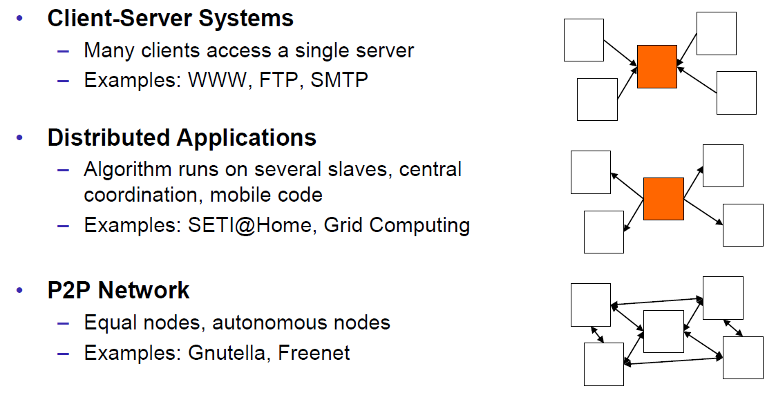

### Classification

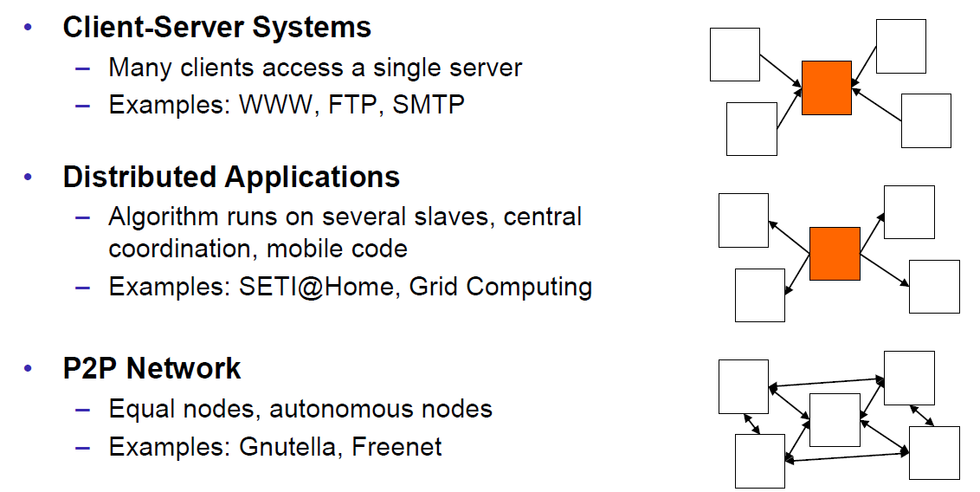

### Pros and Cons

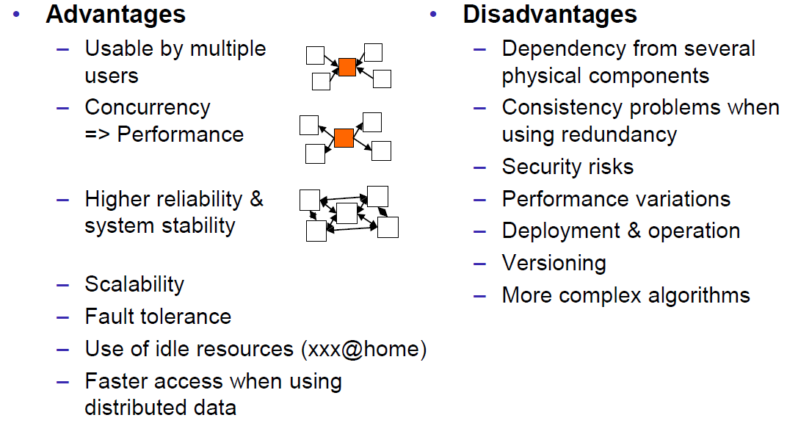

### Interaction Models

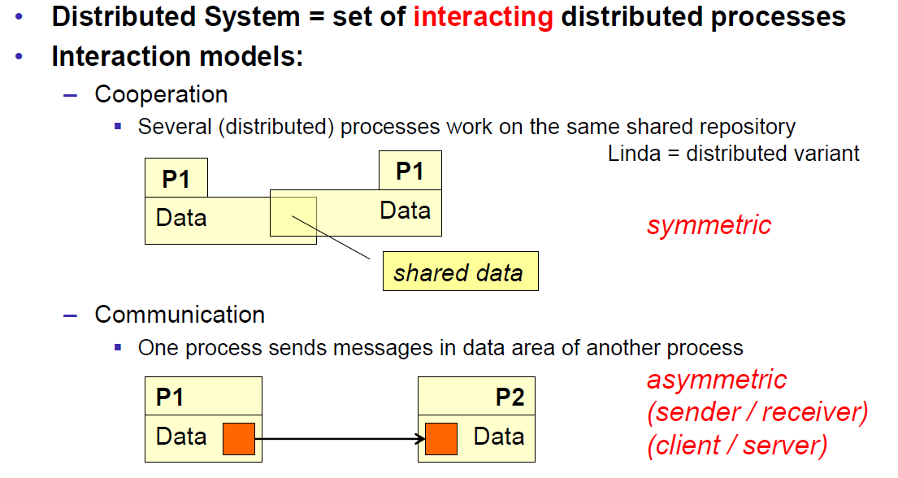

### Client/Server Model

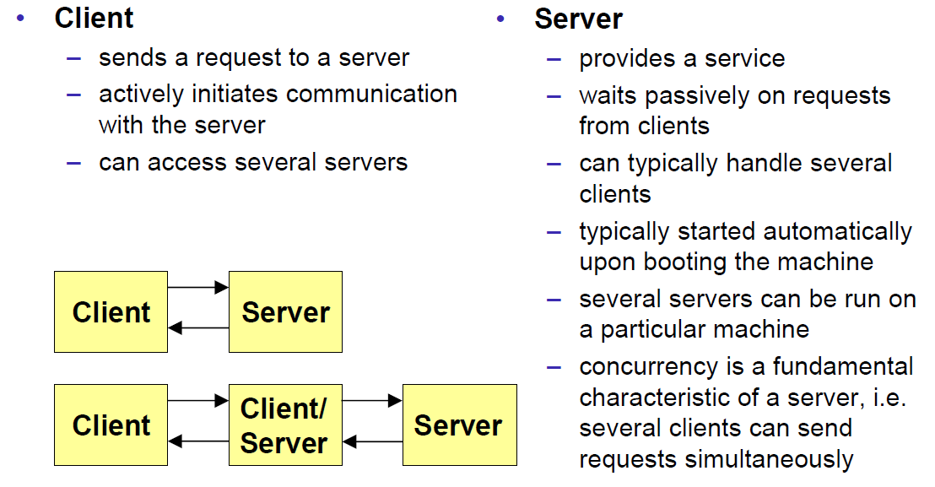

### Communication Models

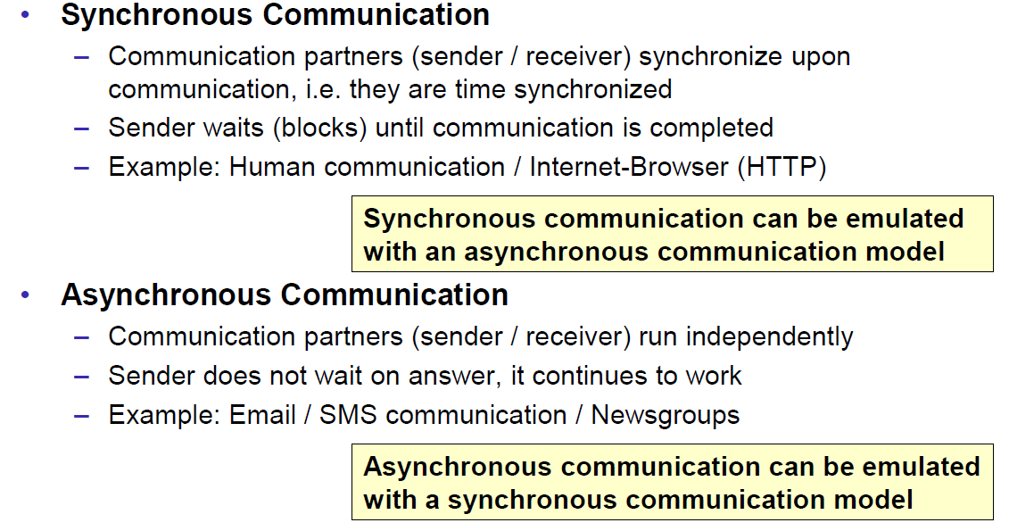

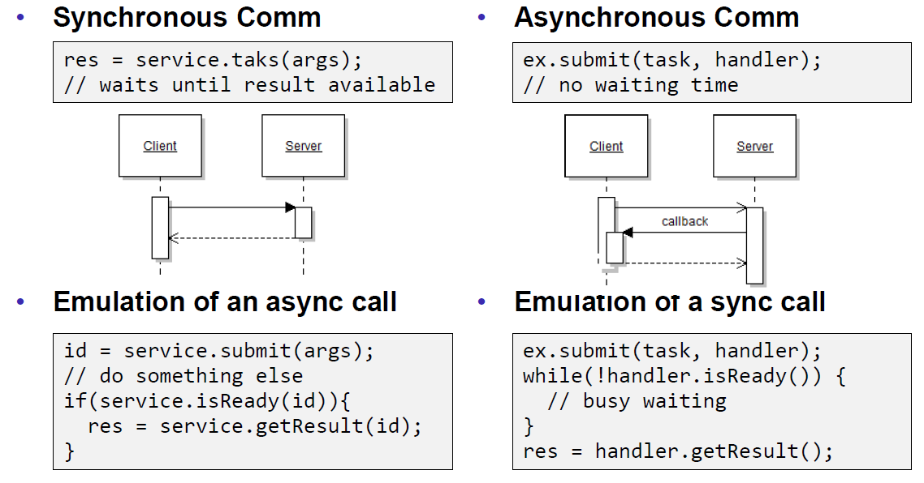

### Communication Styles

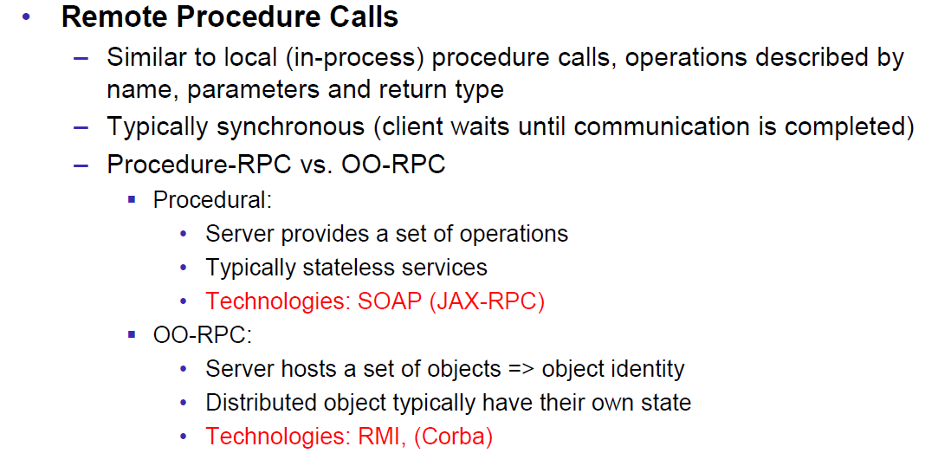

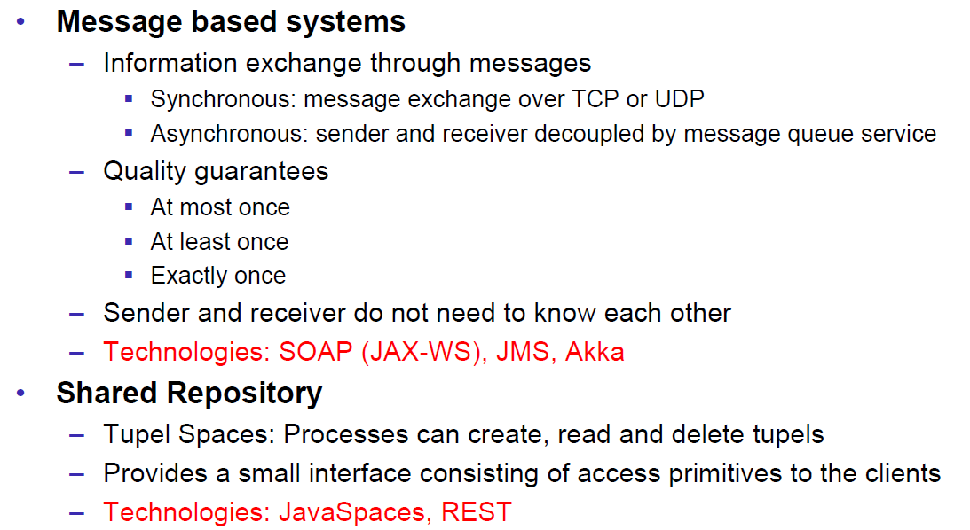

## Challenges of Distributed Systems

### Heterogeneity

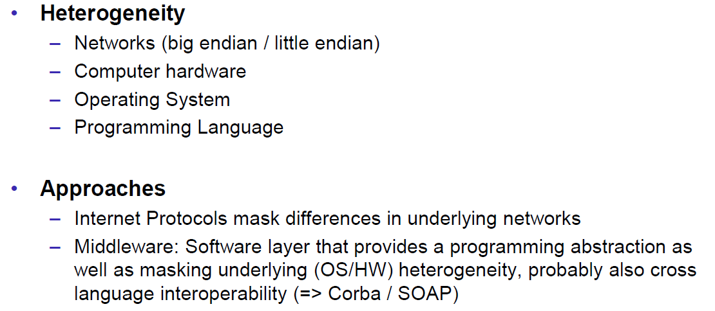

### Latency

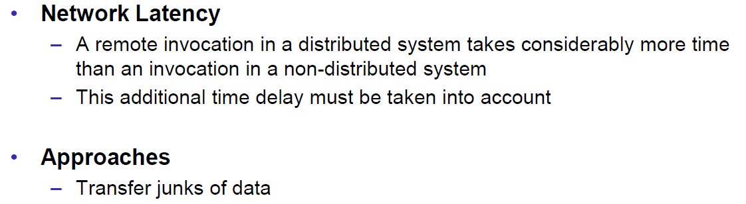

### Security

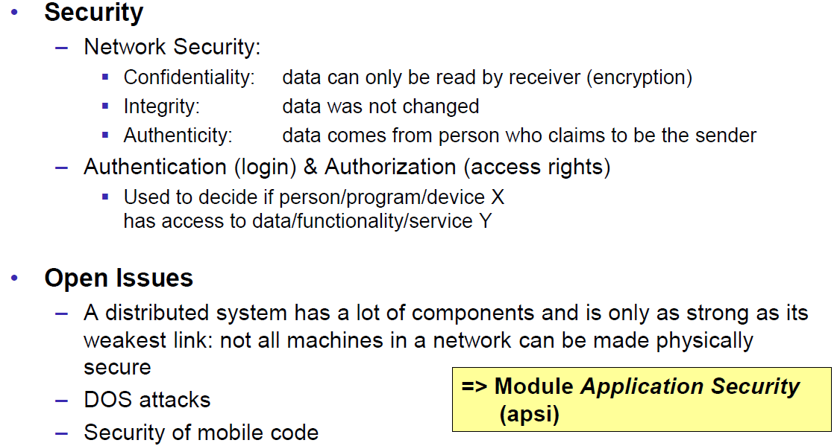

### Scalability

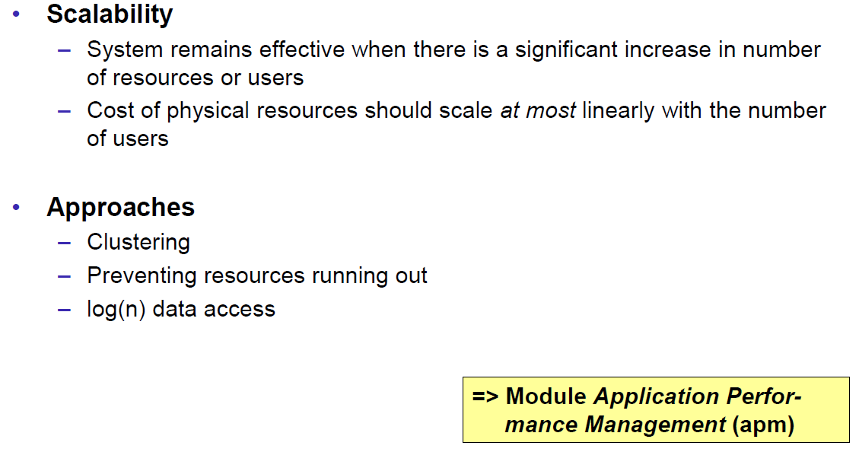

### Failures

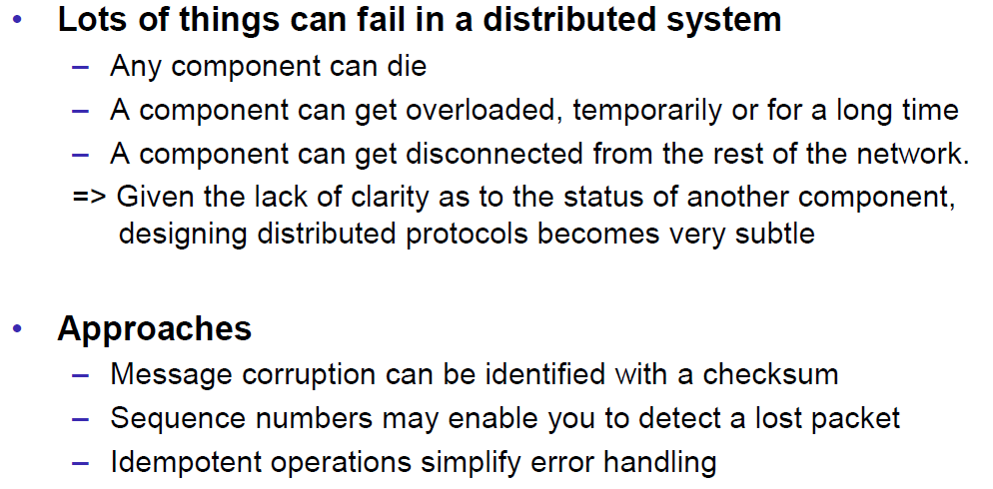

### Concurrency

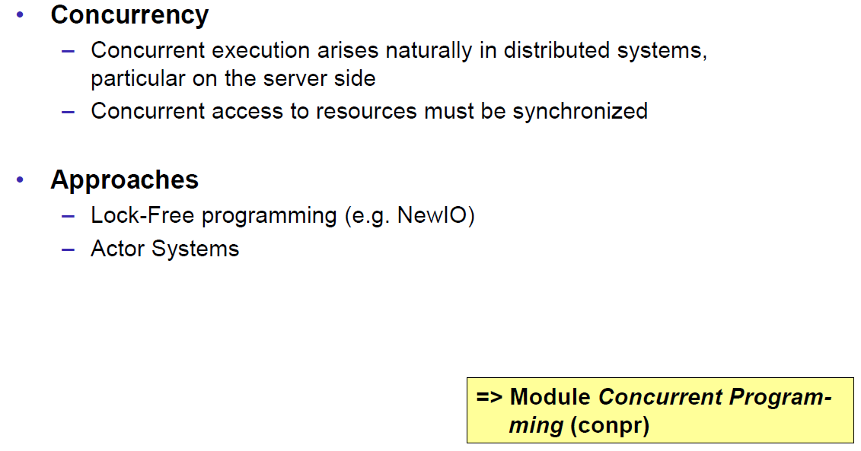

### Consistency

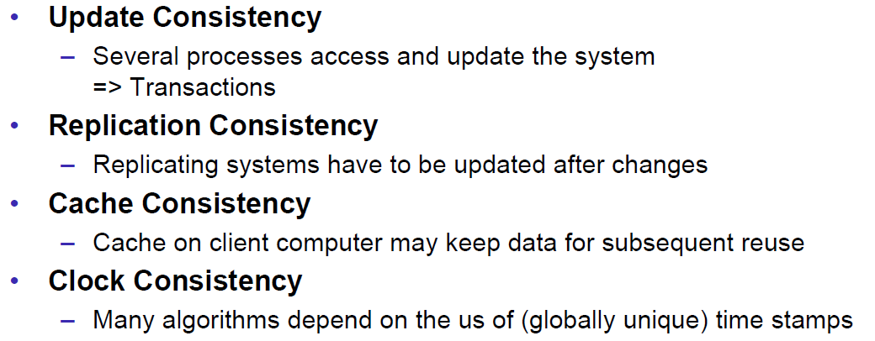

## Networking

### Protocol & Network Levels

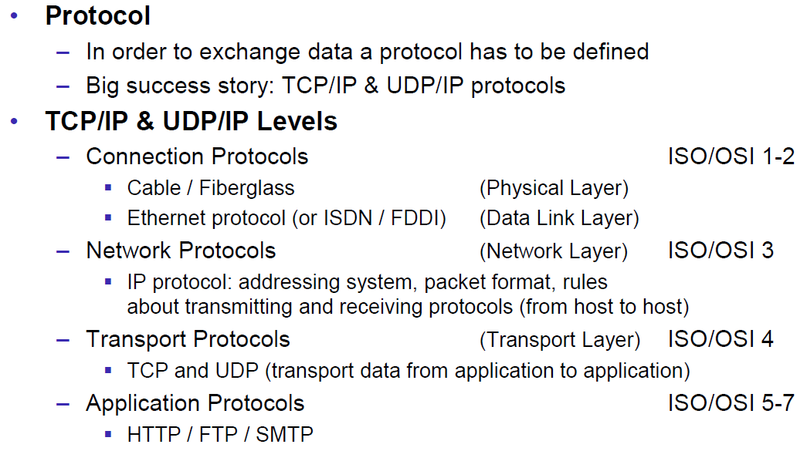

### IP Socket Connections

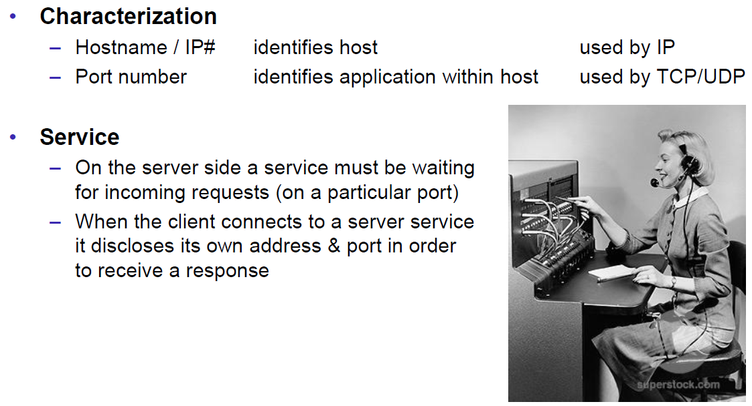

### IP Addressing

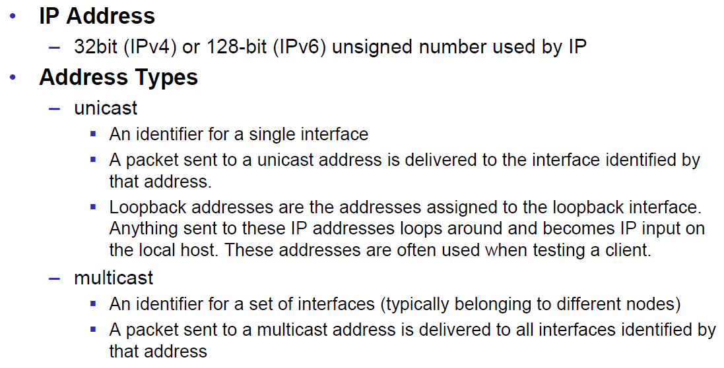

### TCP/UDP Common Port Numbers

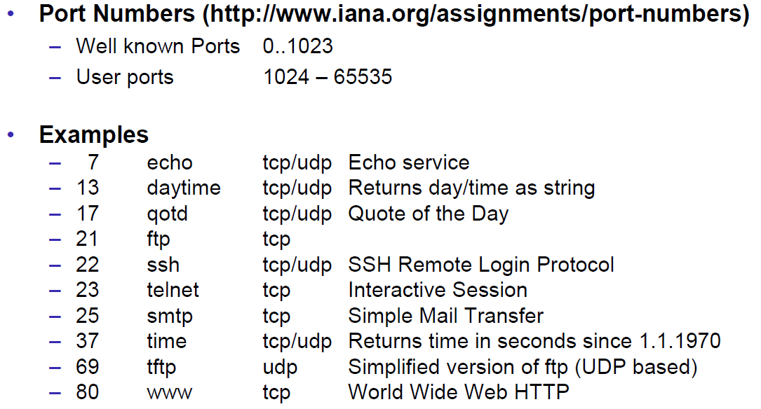

### InetAddress

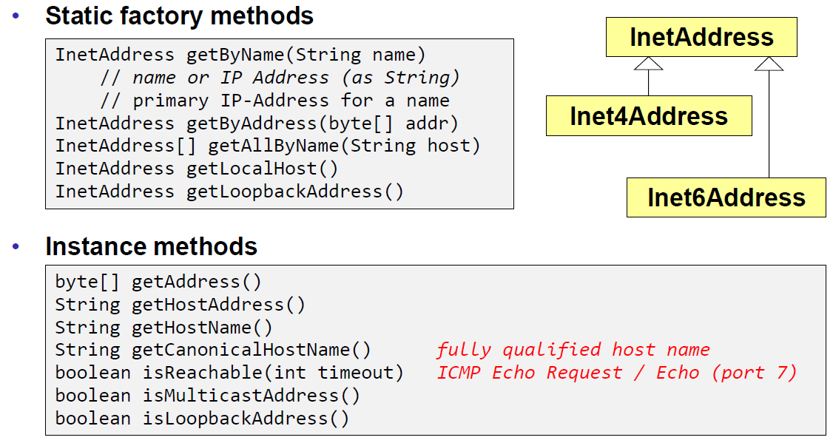

### Network Interfaces

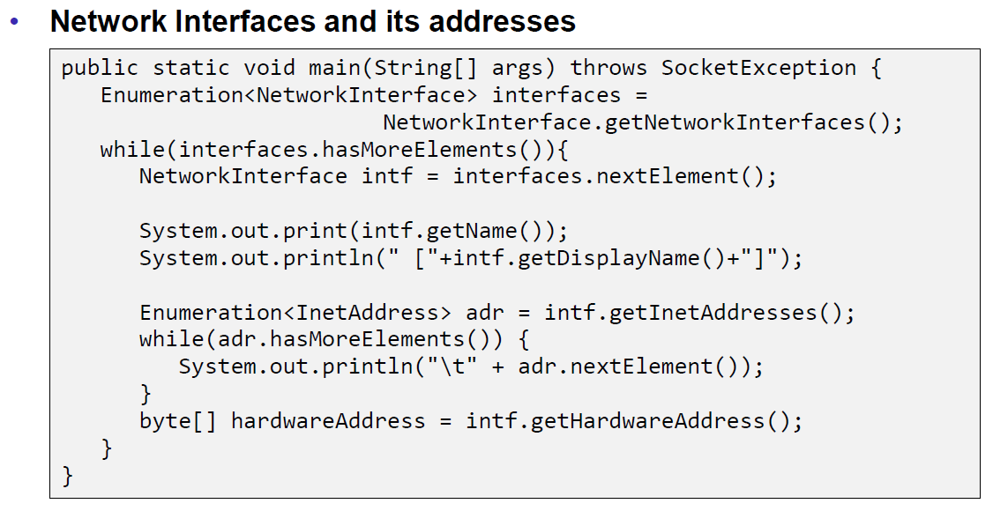

## Sockets

### Sockets

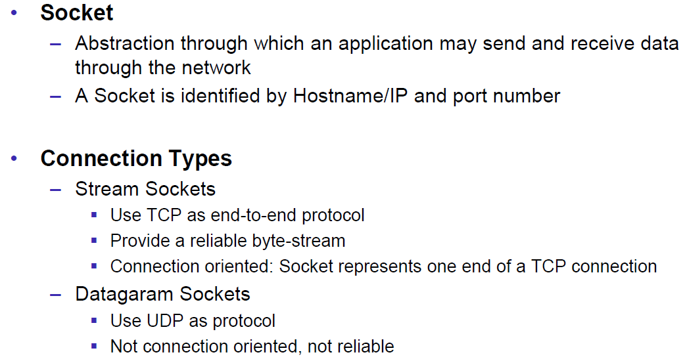

### TCP Sockets

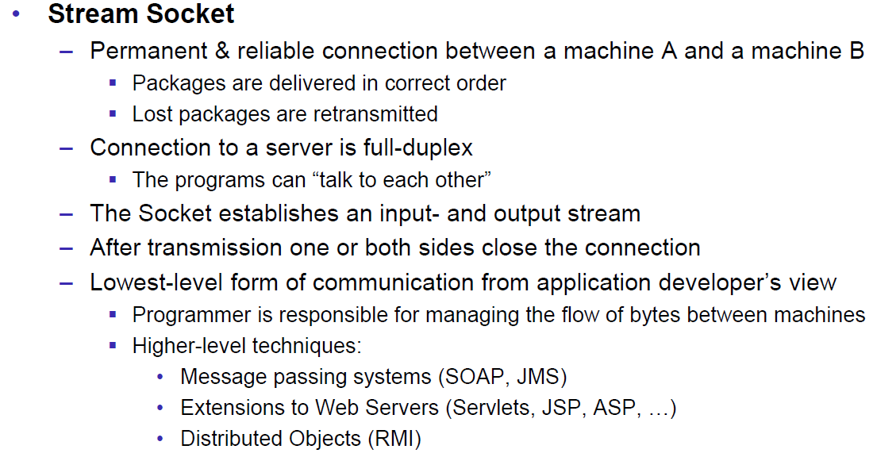

### Java Socket

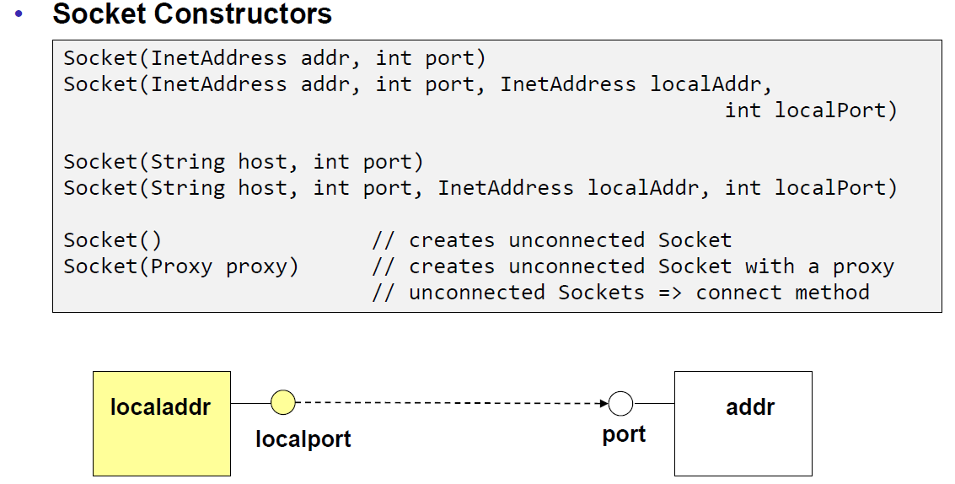

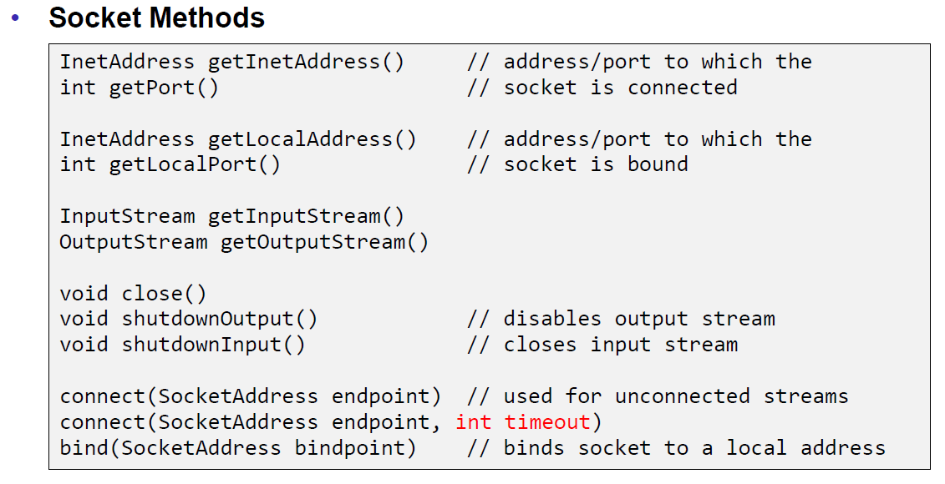

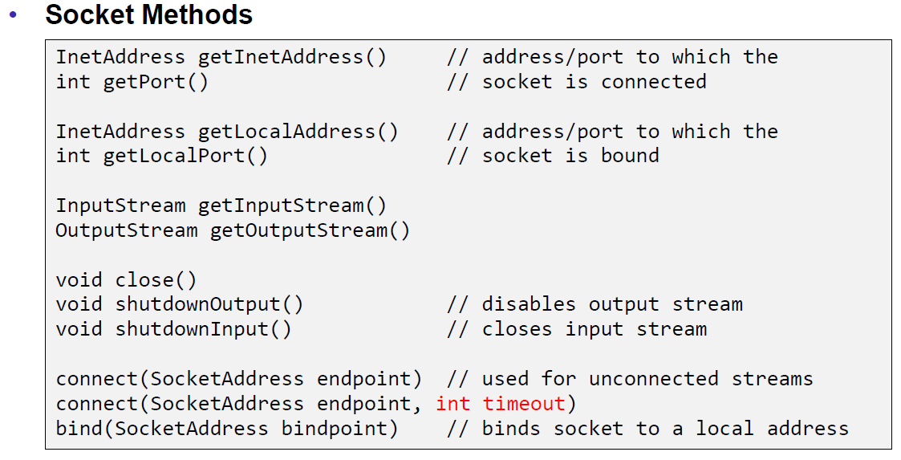

### Sample Client (Echo)

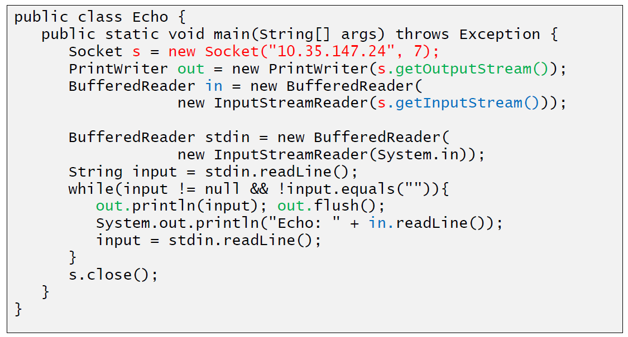

### Sample Client (Mailer)

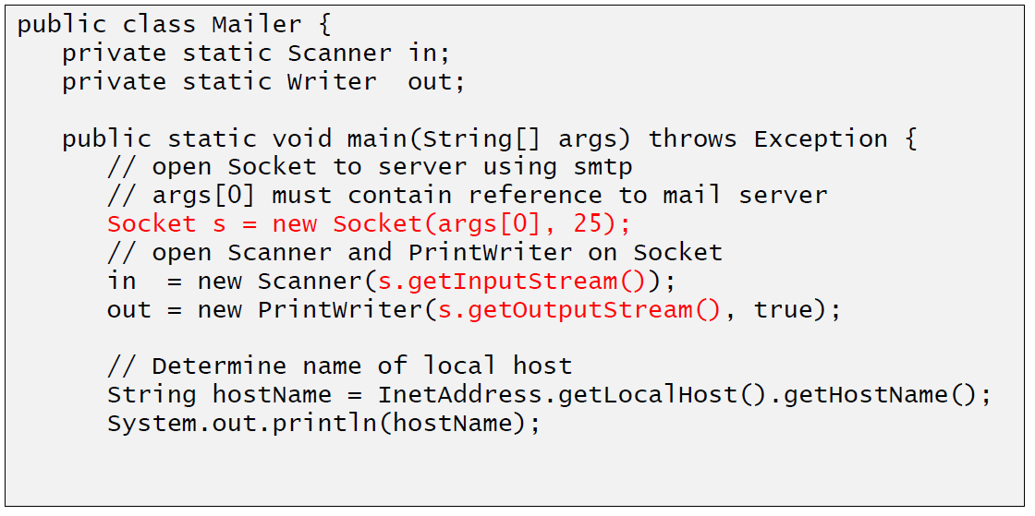

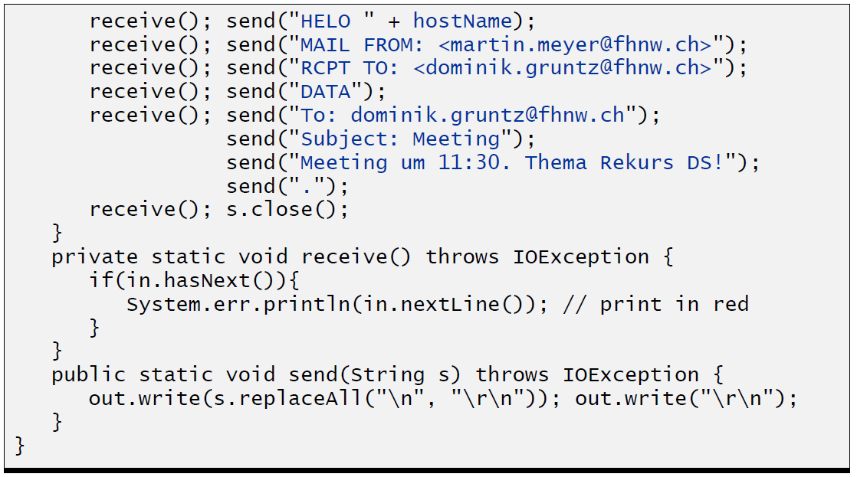

### ServerSocket

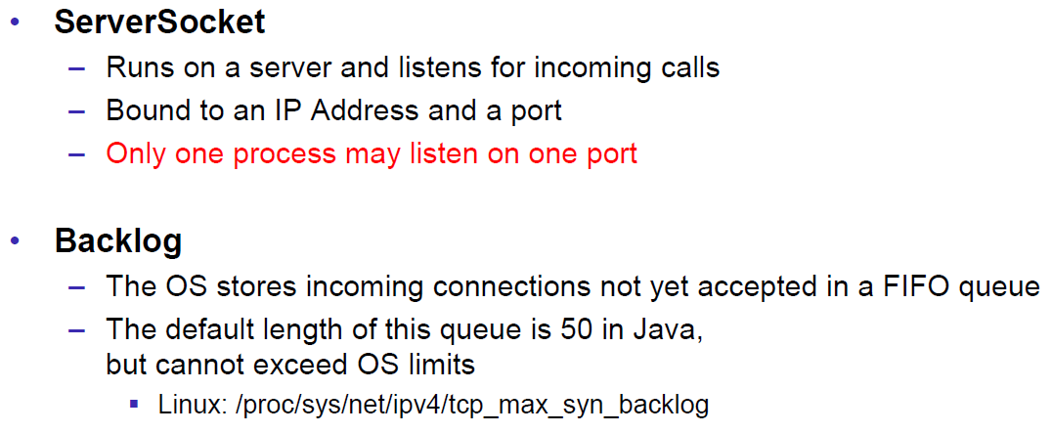

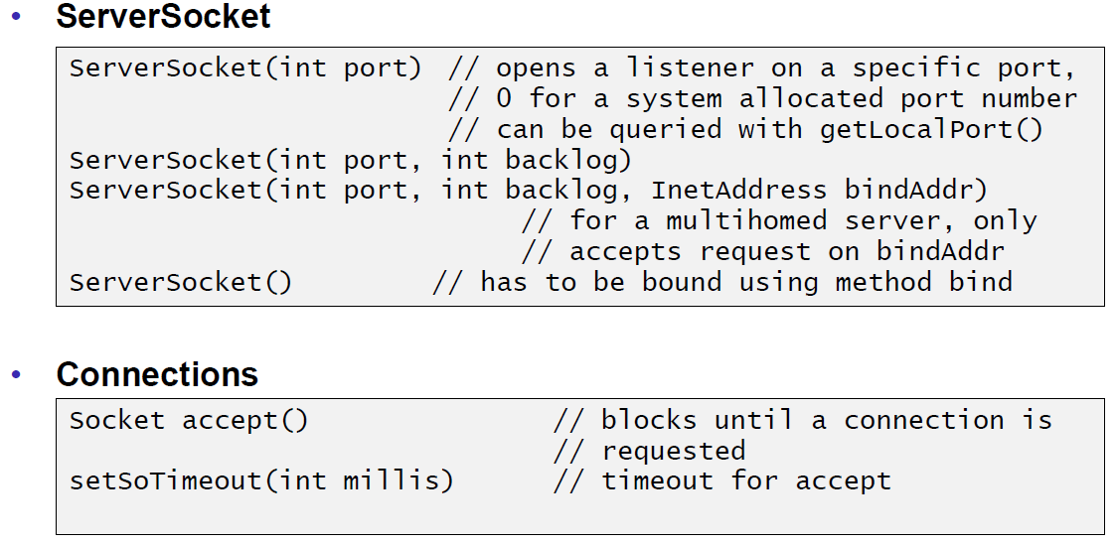

### Echo Server

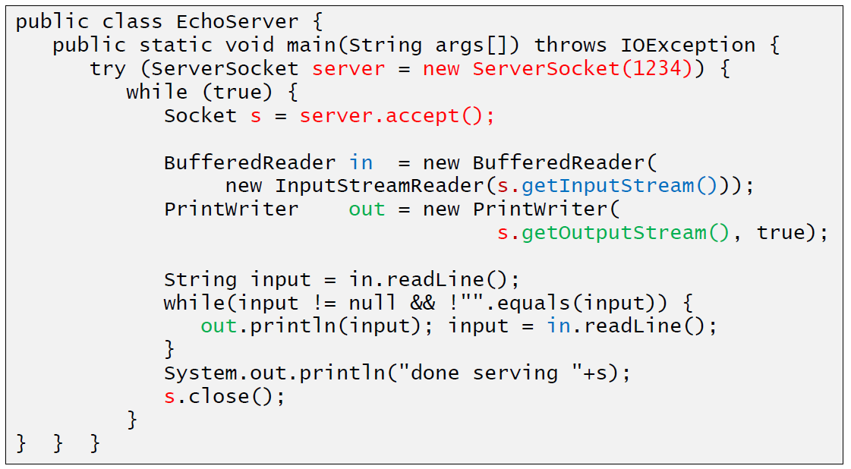

### Concurrent Echo Server

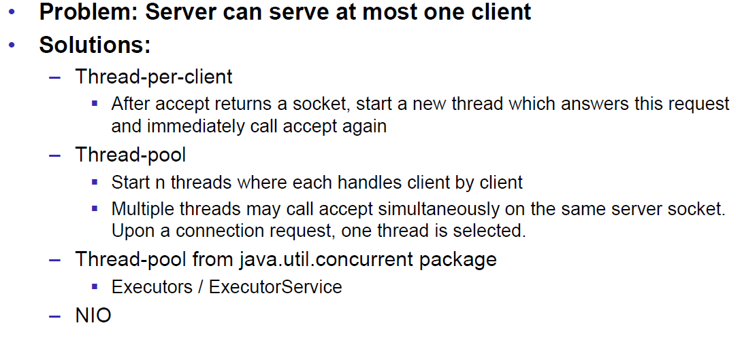

### Concurrent Echo Server (Threaded)

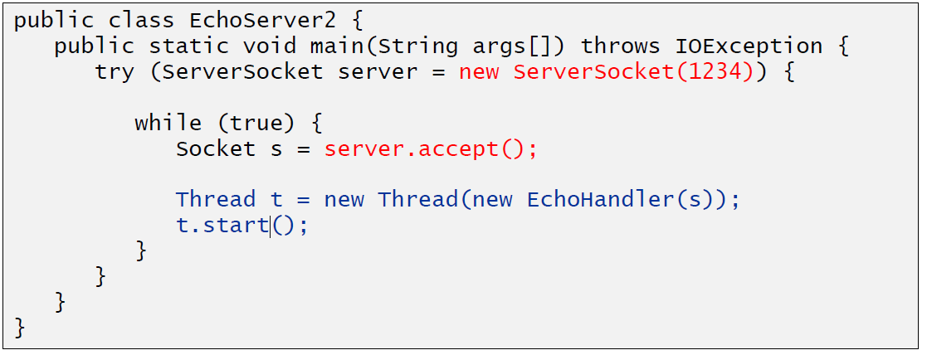

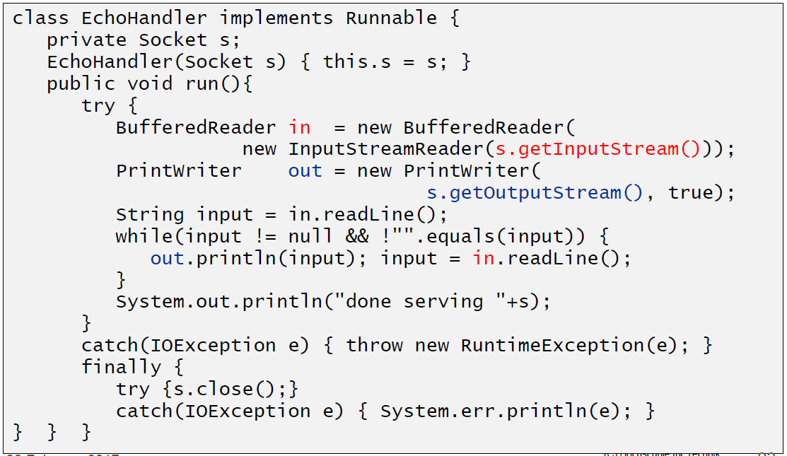

### Concurrent Echo Server (Limitierter Threadpool)

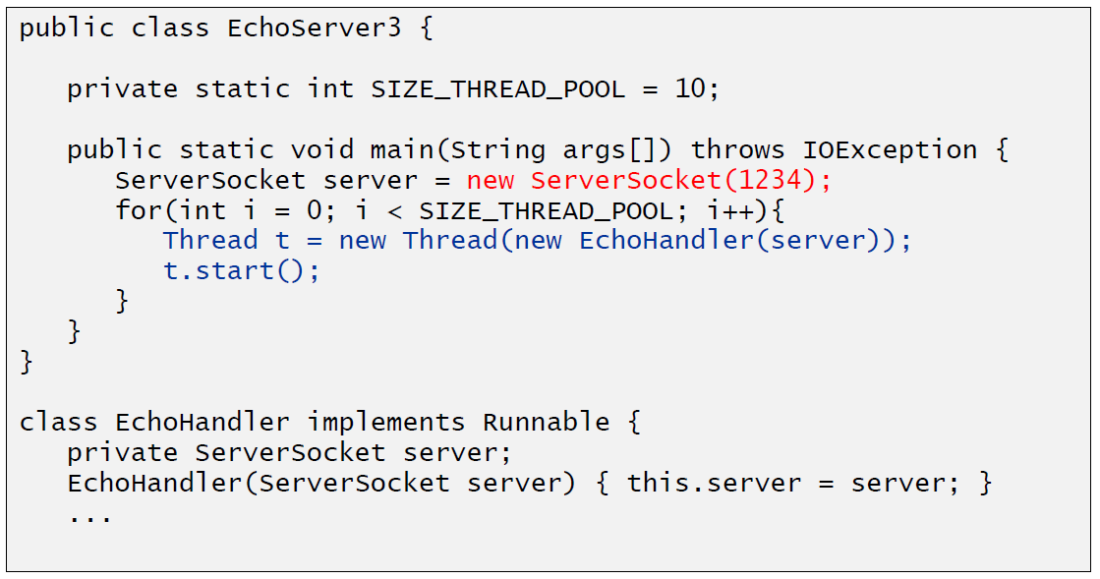

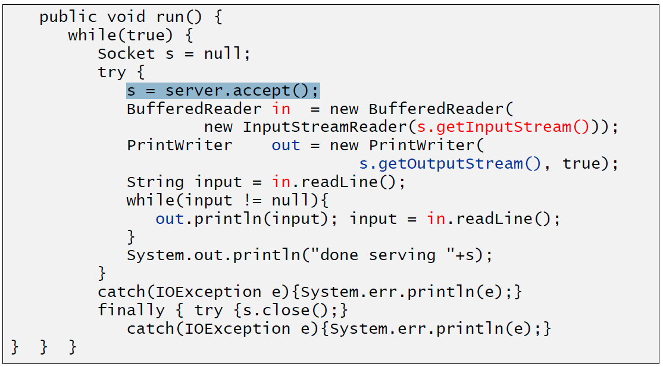

### Concurrent Echo Server (Dynamischer Threadpool)

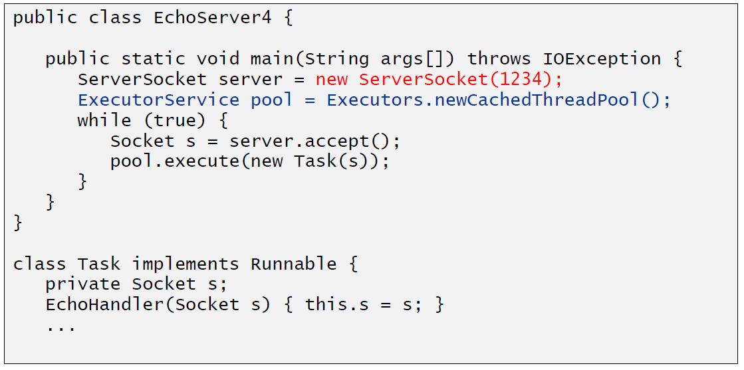

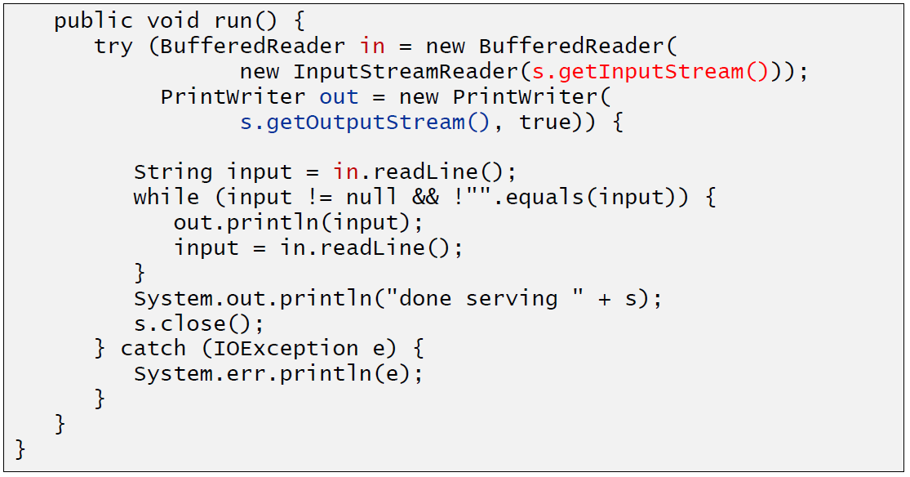

# Woche 2

## Input and Output Streams

### OutputStream

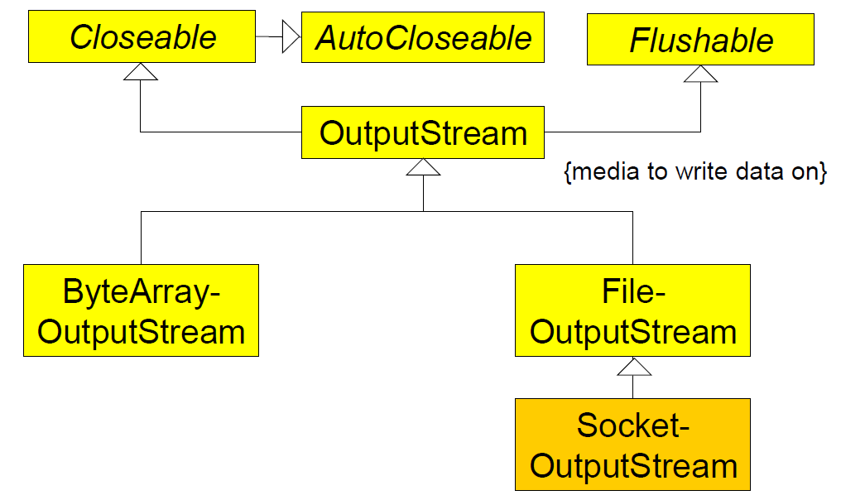

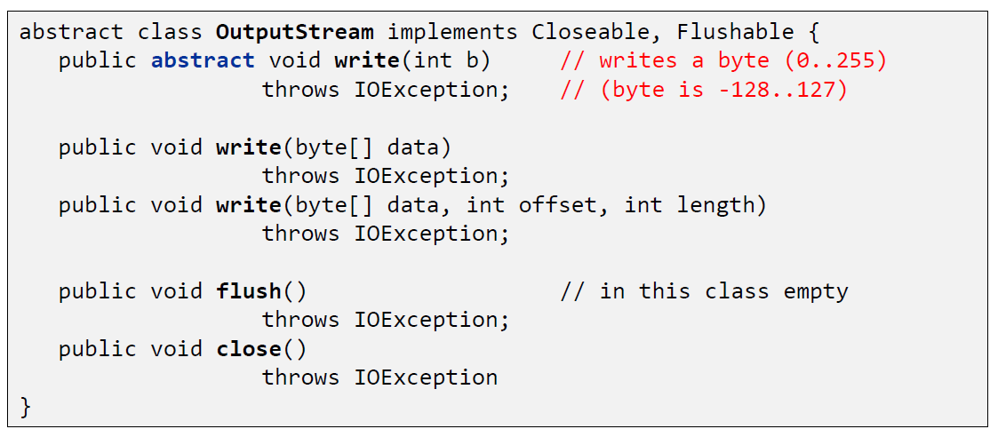

### InputStream

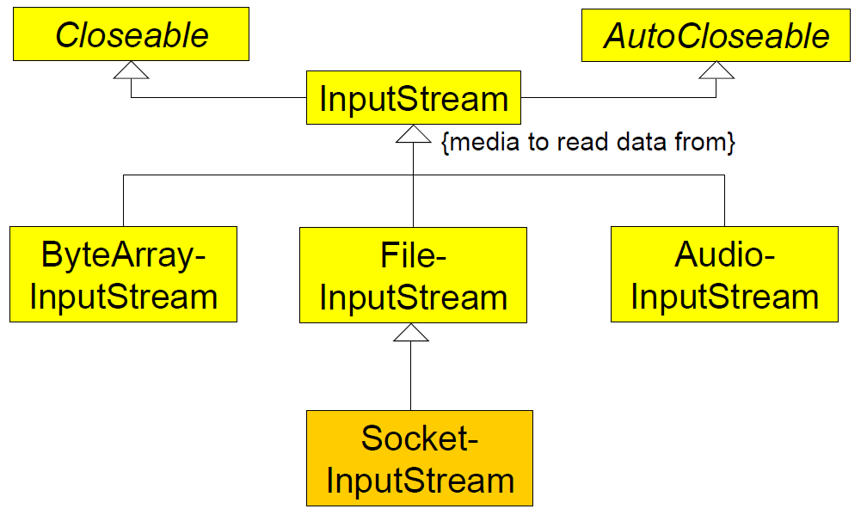

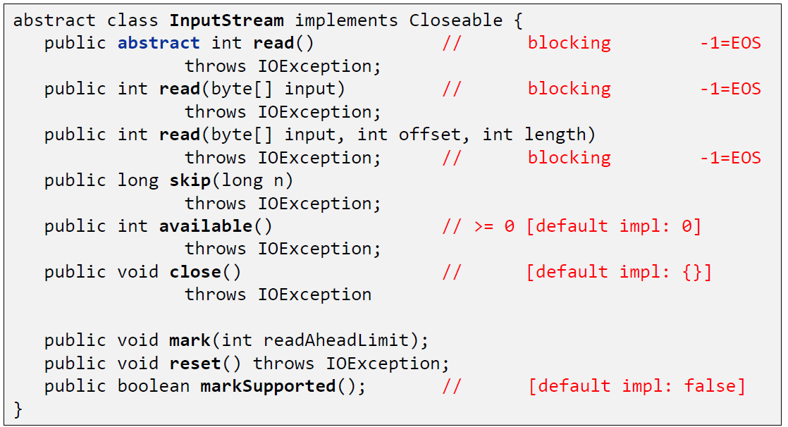

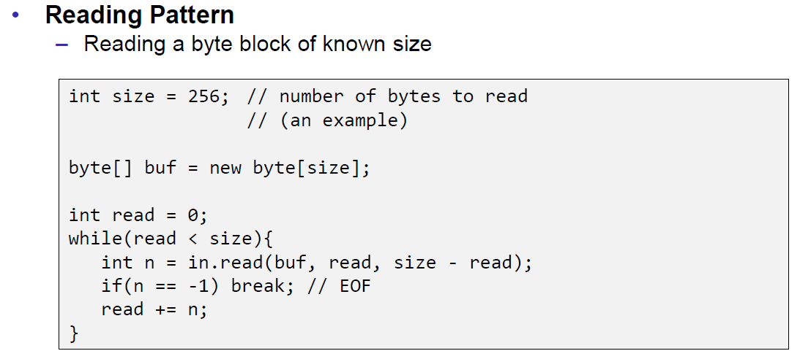

## Filter Streams

### FilterOutputStream

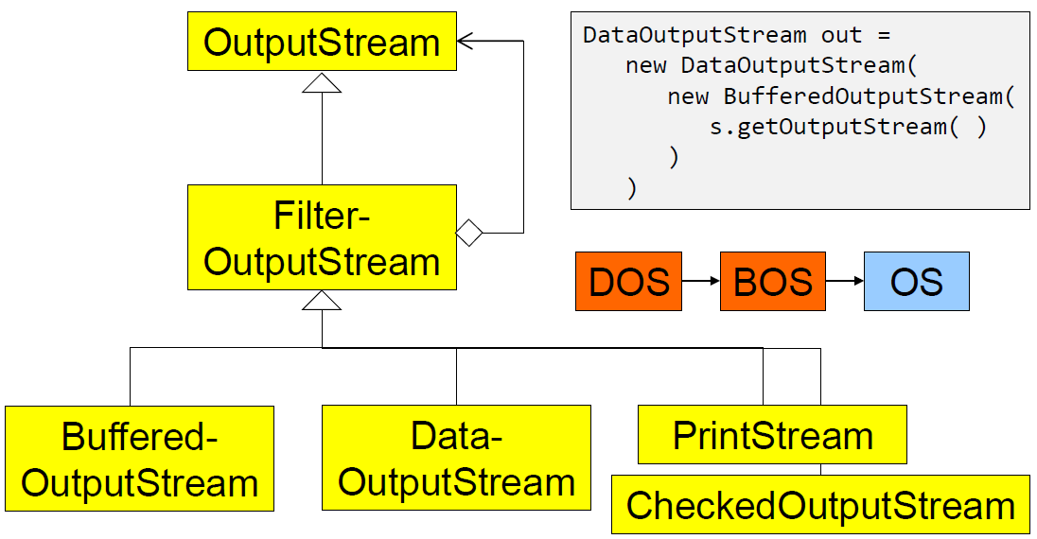

### DataOutputStream

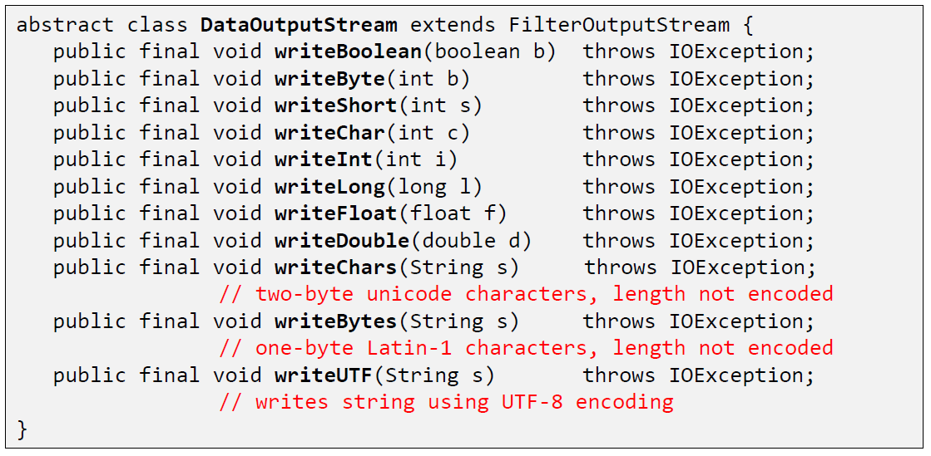

### DataOutputStream with writeInt

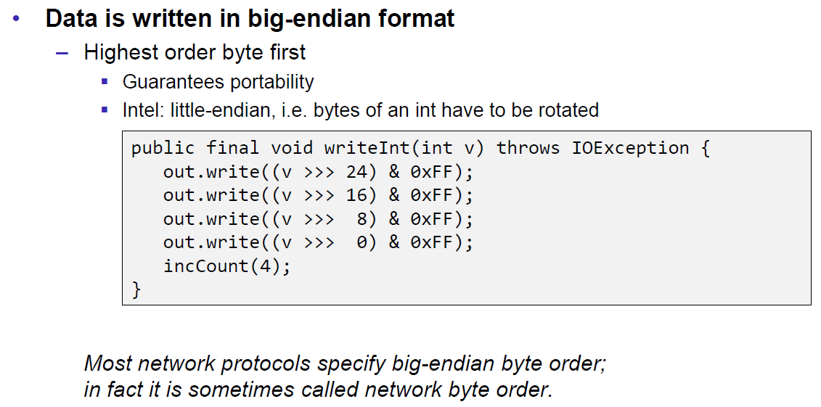

### DataOutputStream with writeUTF

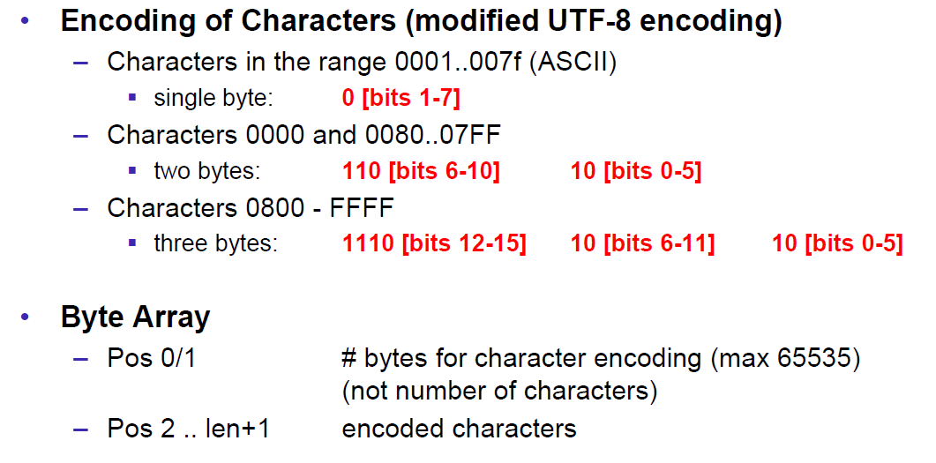

### PrintStream

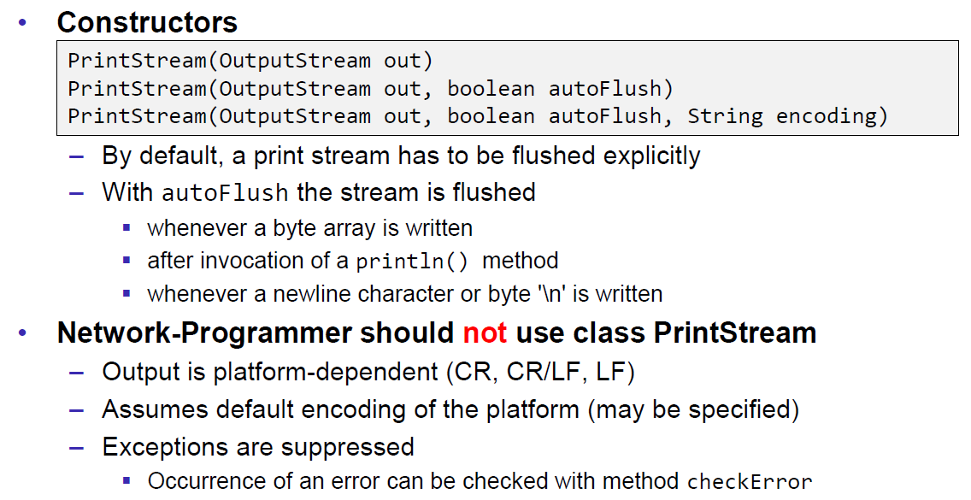

### FilterInputStream

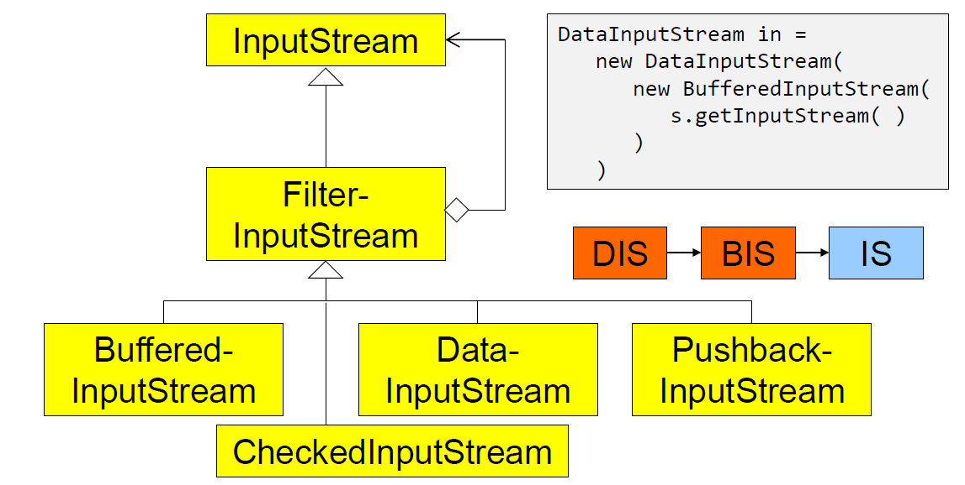

### DataInputStream

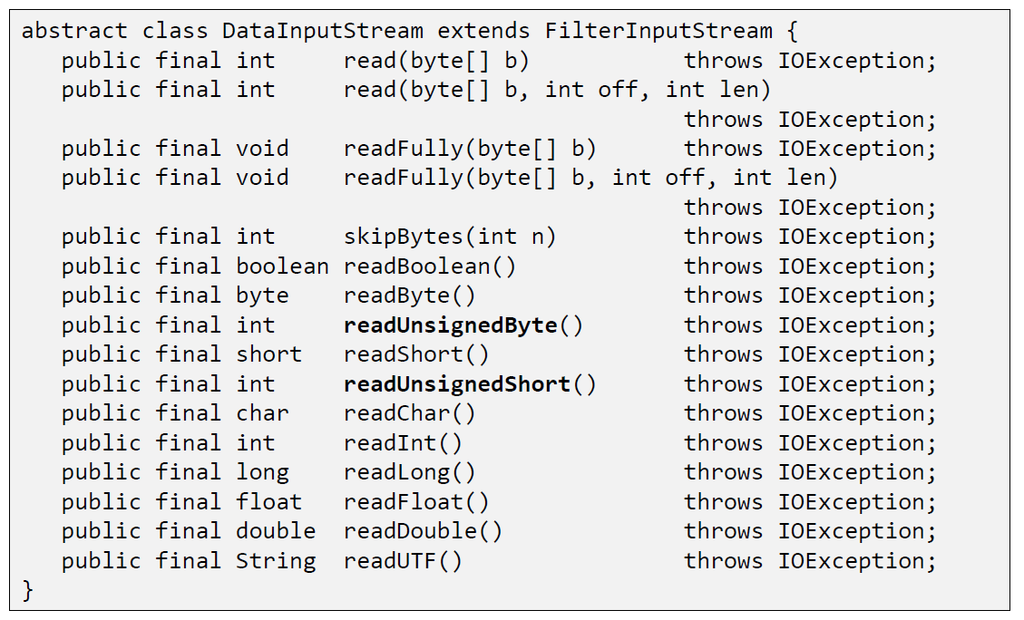

### DataInputStream with readFully

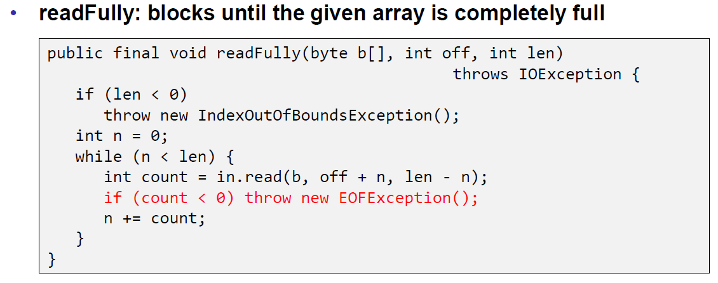

### Filter Streams

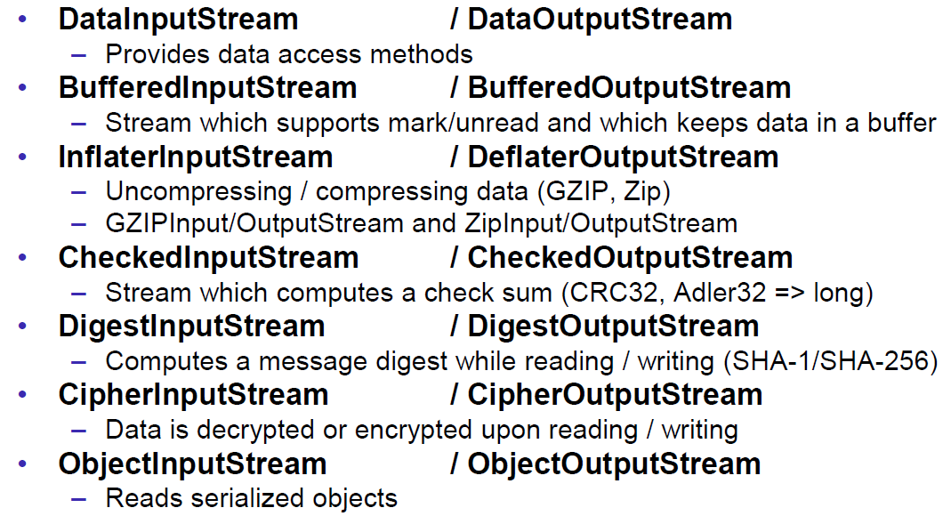

## Object Streams & Serialization

### ObjectStream

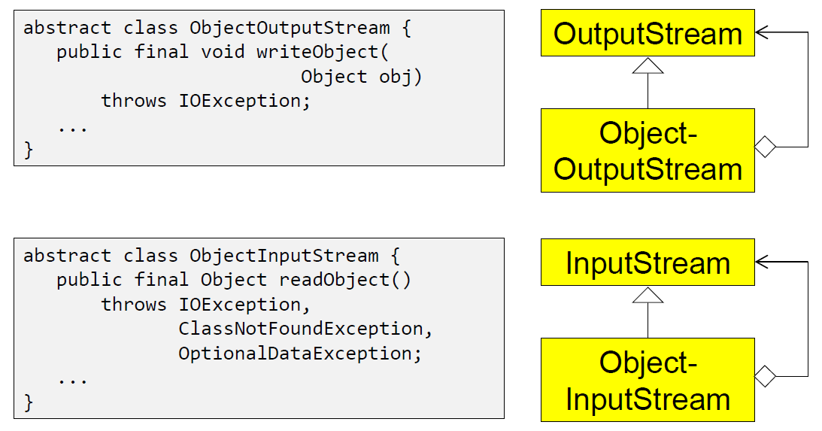

### Serialization with ObjectStream

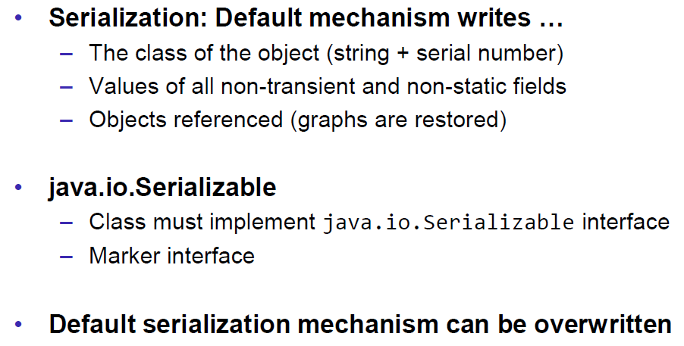

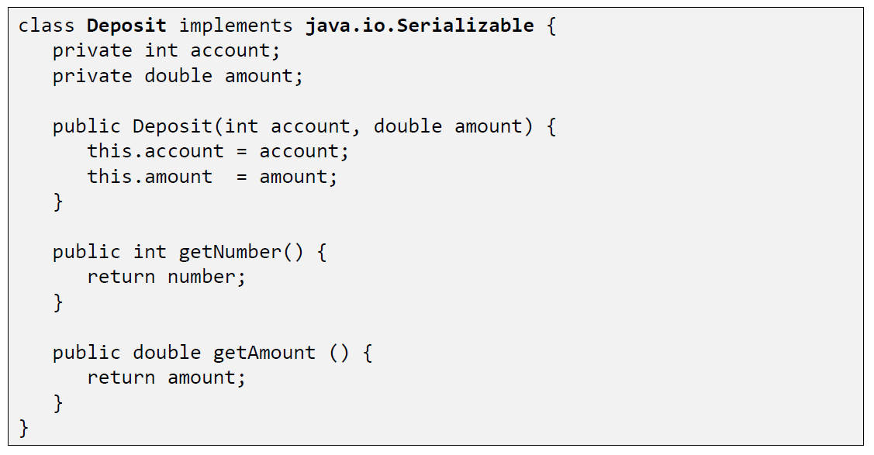

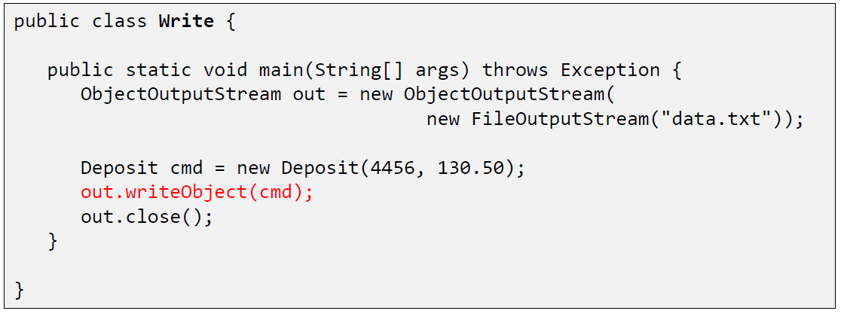

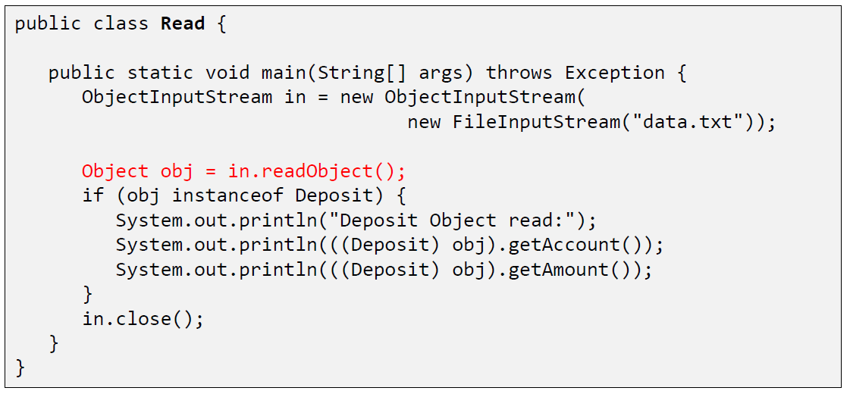

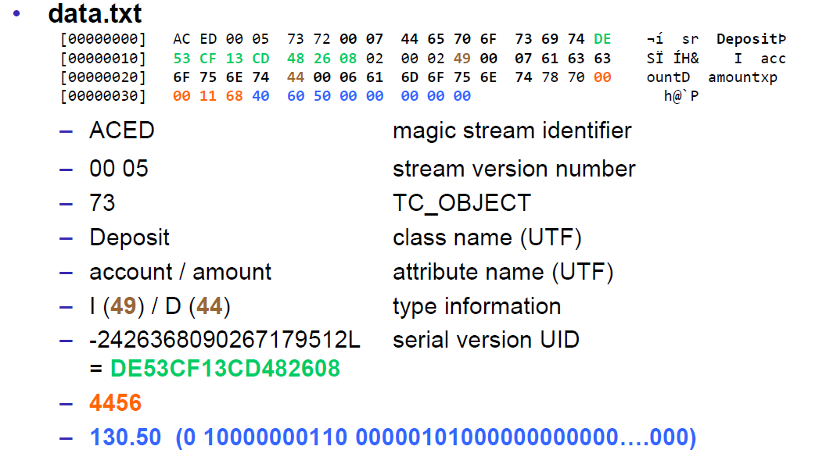

### Serial Version Number

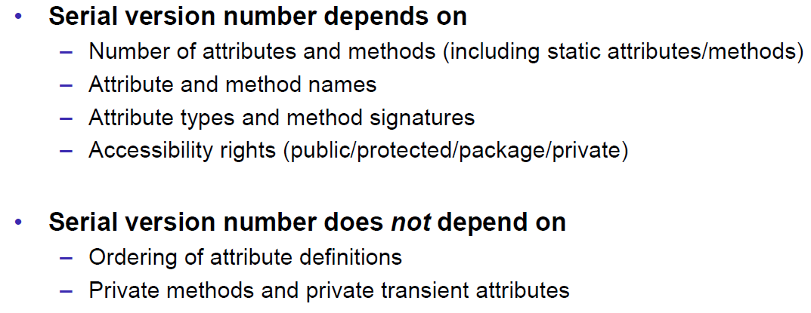

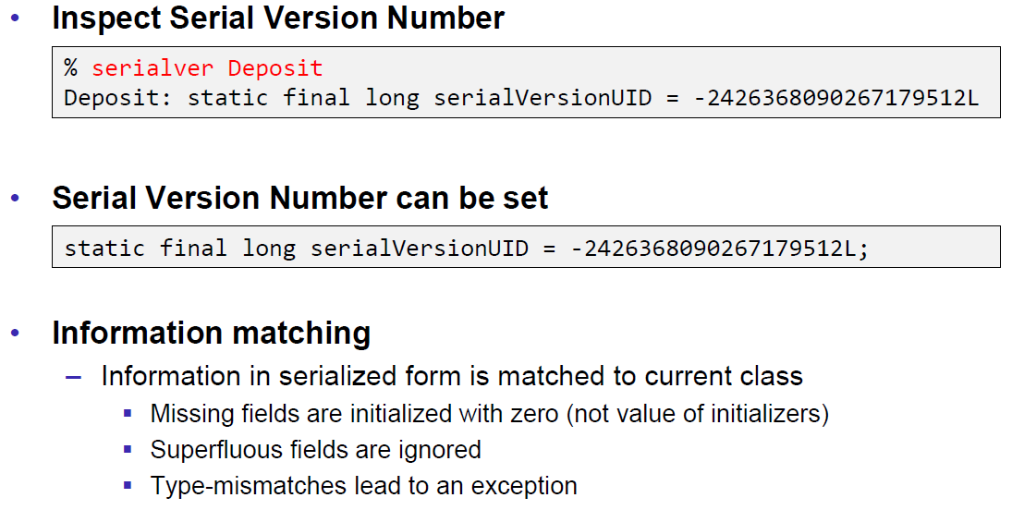

### Serialization Customization

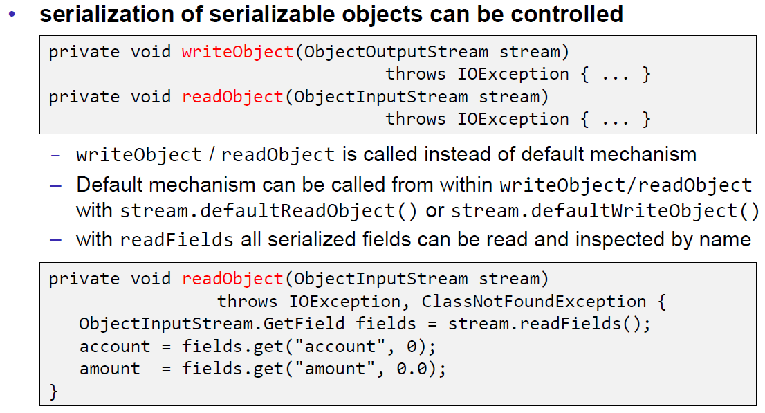

### Serialization Hints

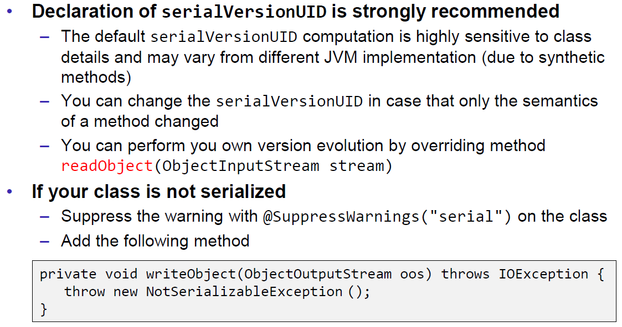

## Sending and Receiving Data

### Framing

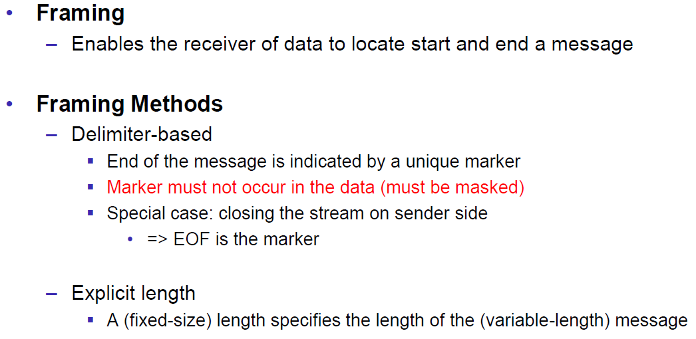

### Example of Framing

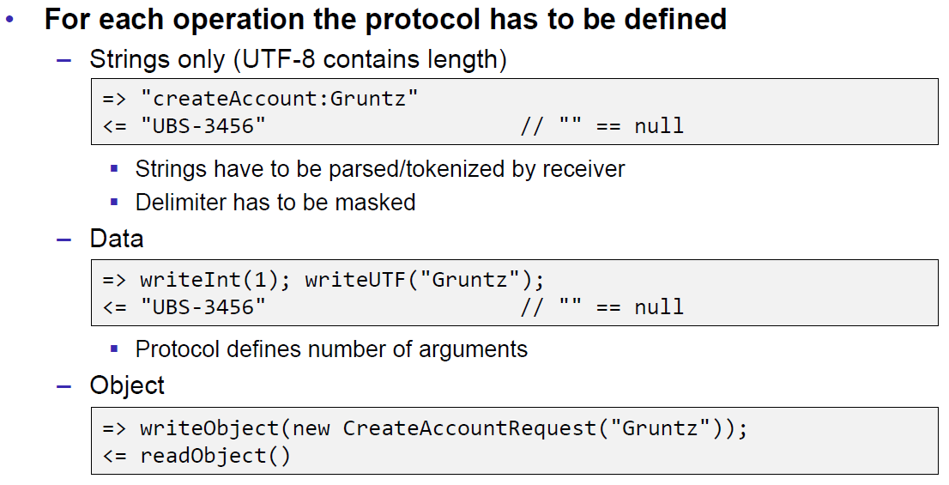

## Summary

### Whole Picture of Input Streams

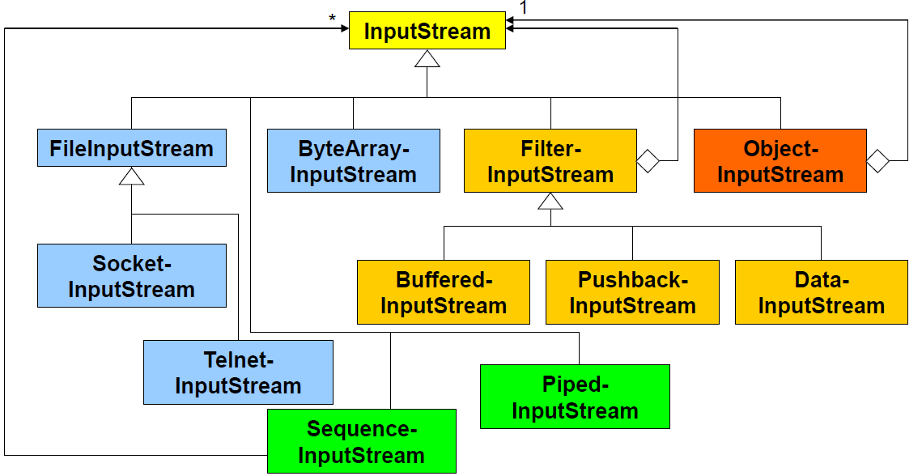

### Whole Picture of Output Streams

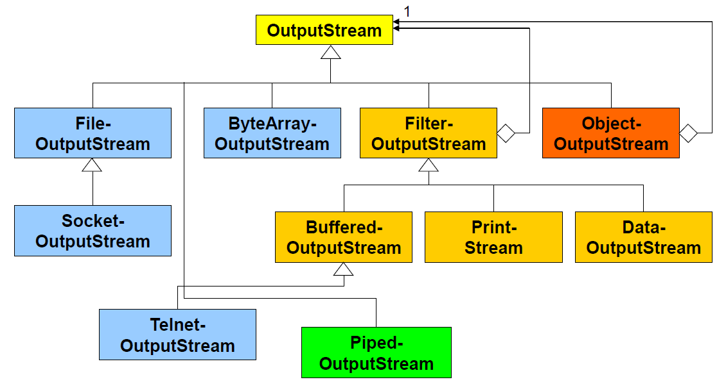

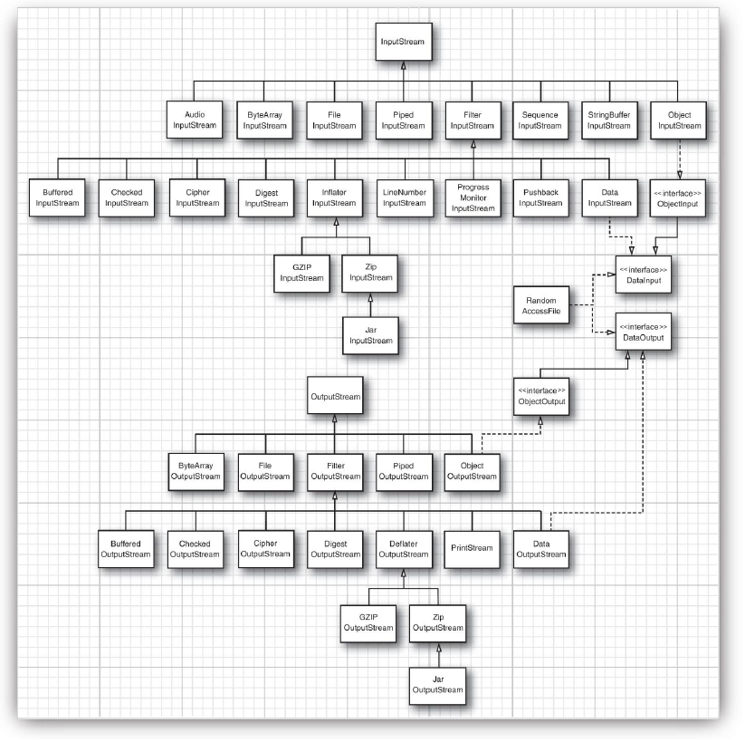

### Reading and Writing Text (Unicode Strings)

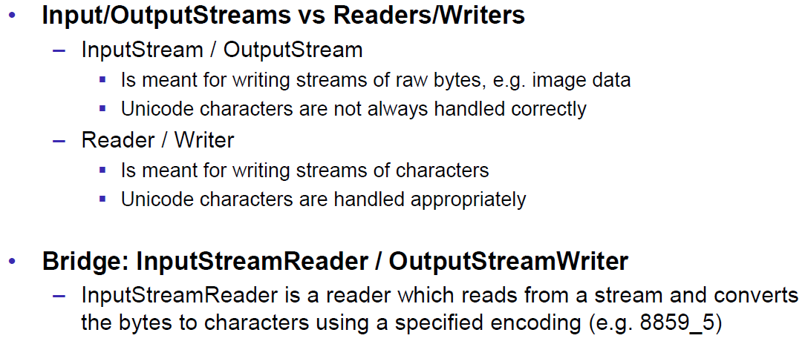

### Whole Picture of Reader

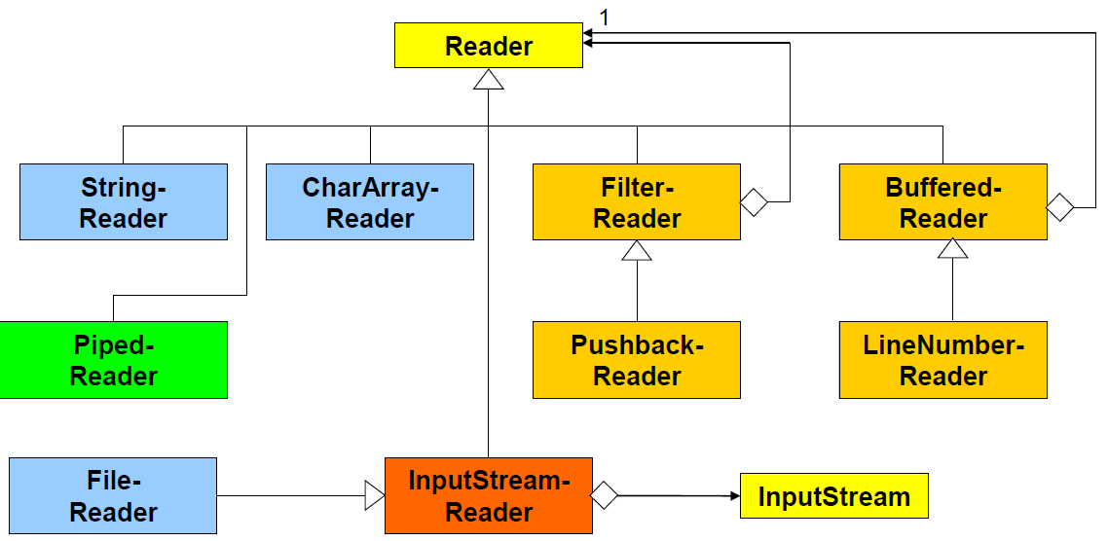

### Whole Picture of Writer

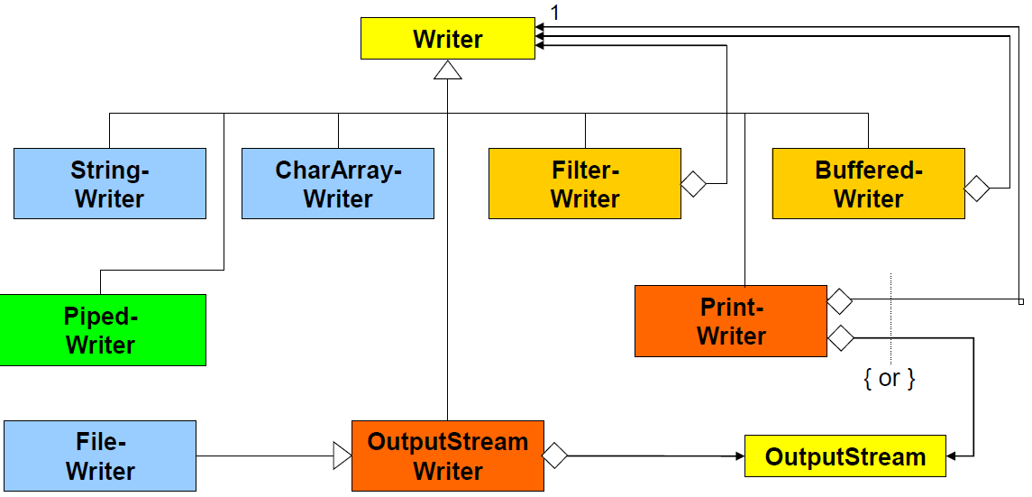

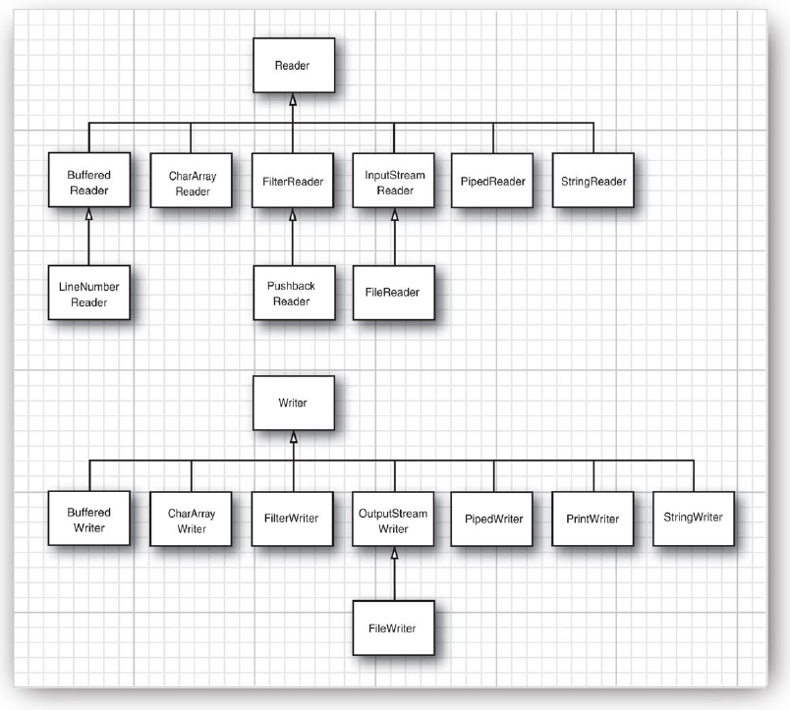

## Controlling Socket Behaviors

### Blocking and Timeouts

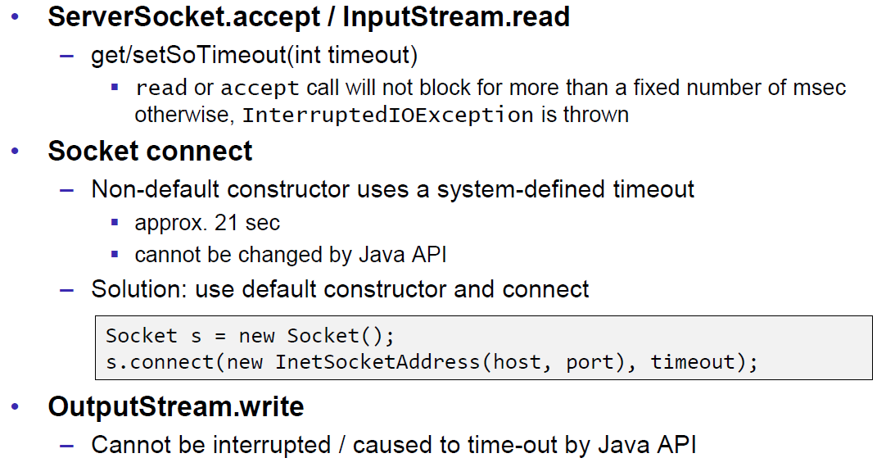

### Send and Receive Buffer Size

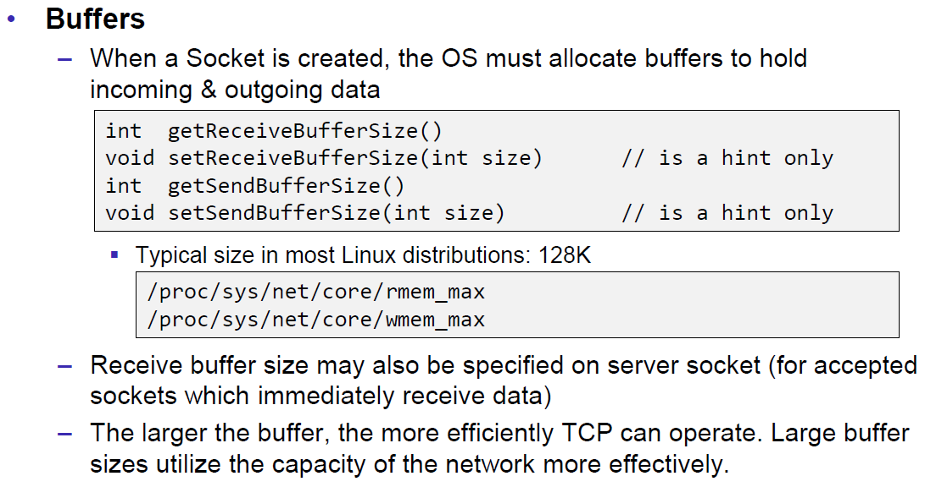

### Package Delay

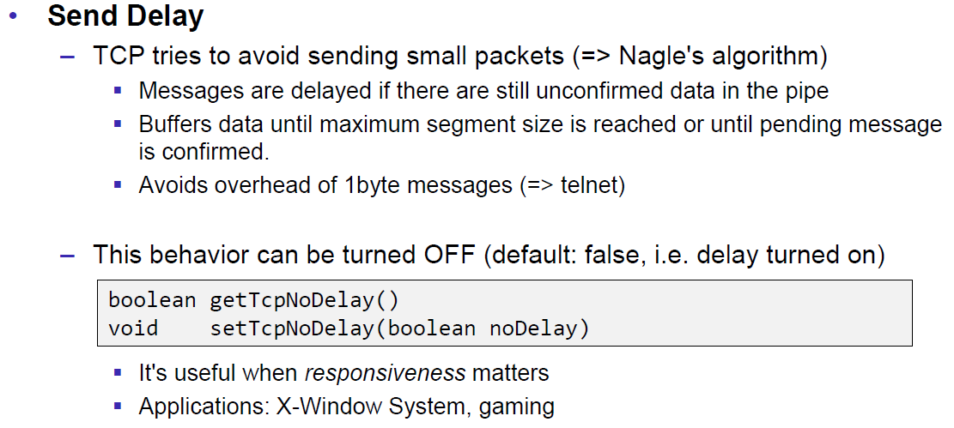

## Closing Connections

### Closing Connections

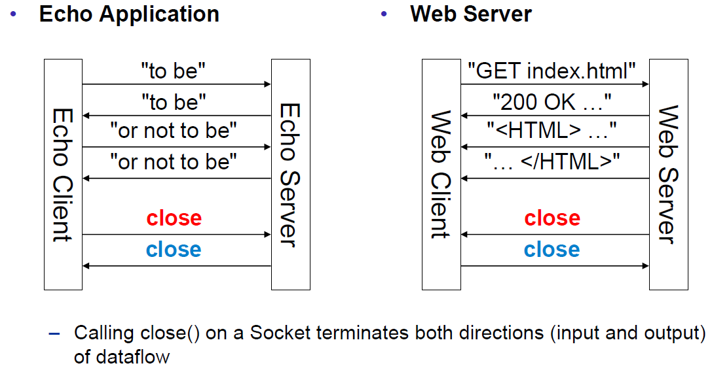

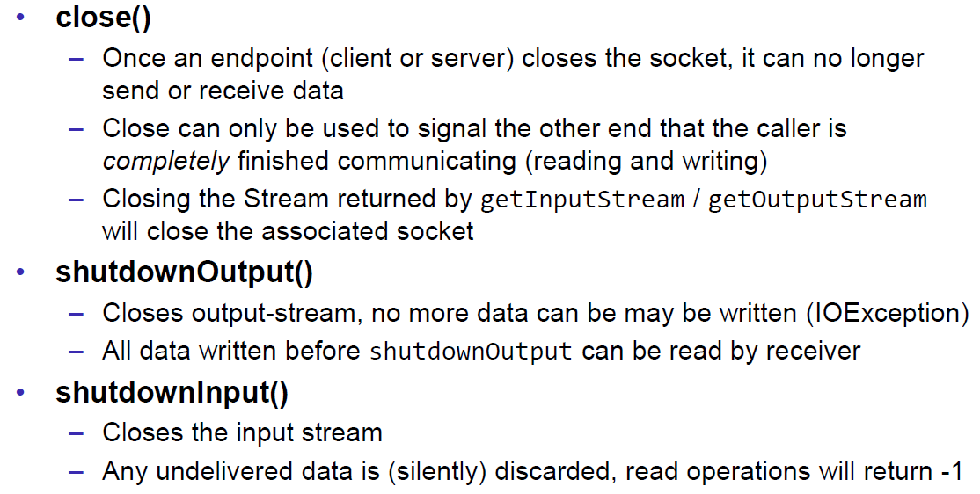

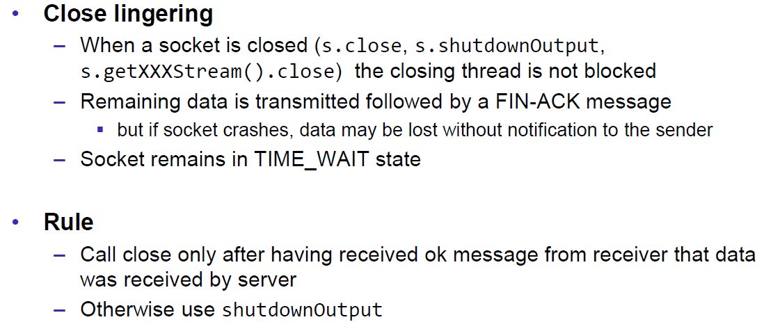

### Example of a Close Test

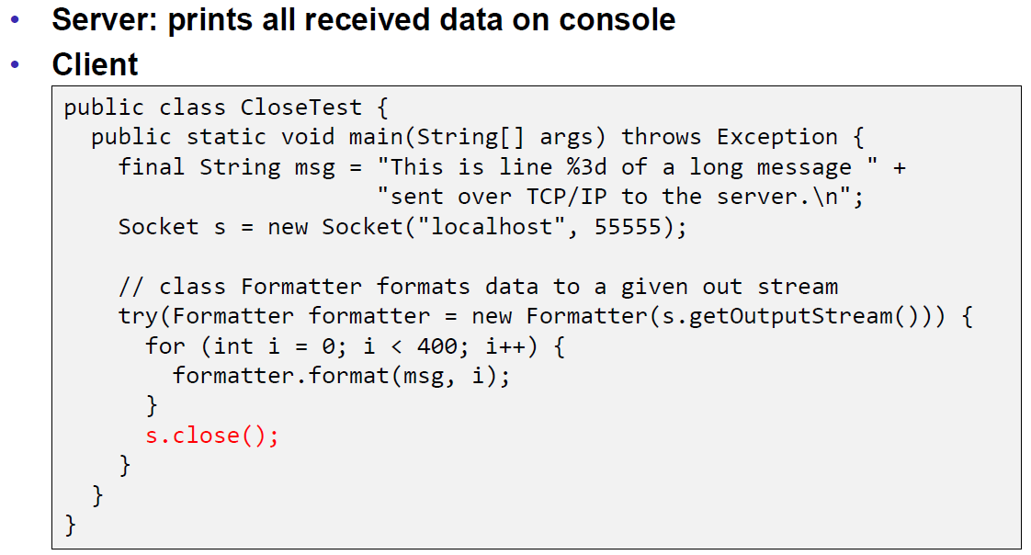

Problem: Some content of the formatter is not received by the server.

Solution: Flush the formatter before you close the socket, otherwise the buffer of the formatter won’t be sent.

### Example of a Compression Server

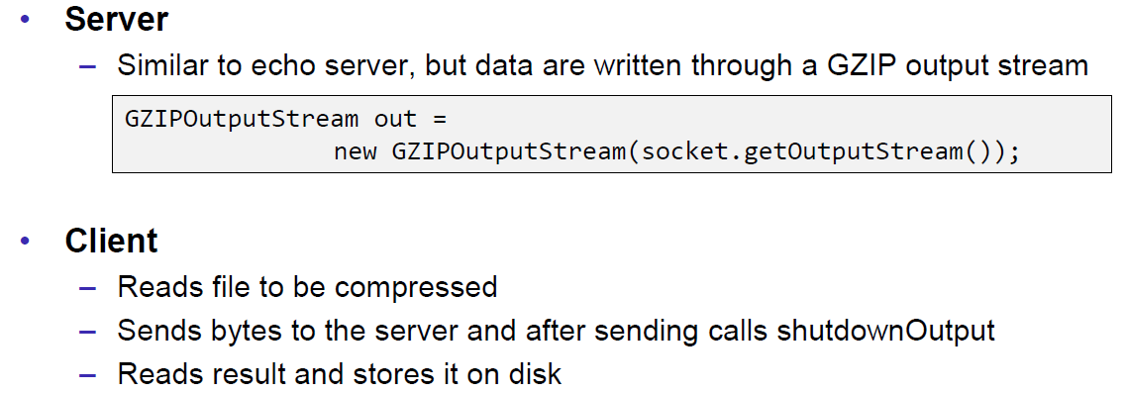

Problem: At some point, the server hangs up and doesn’t reply anymore.

Solution: Don’t send all content before you start reading. Otherwise you will fill up the outgoing (sending) cache of the server (because no one is reading it) and the write process of the server becomes blocking (this prevents a data loss because the outgoing buffer is full). A solution to this problem is to write and read block by block or to start the send process in a separate thread (Both happens in the client), so the client is able to immediately read the result and prevents a full sender buffer of the server.

## UDP Sockets

### UDP (User Datagram Protocol)

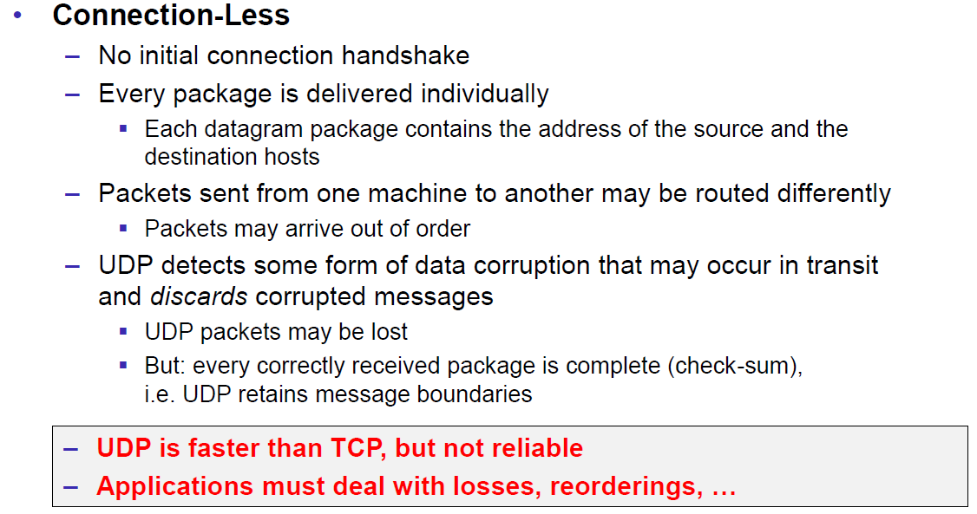

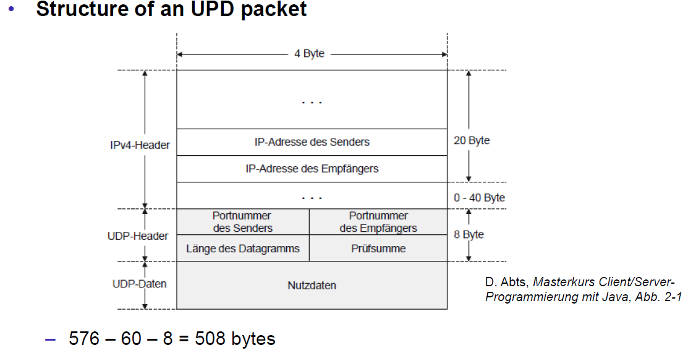

### Java Classes for Datagram

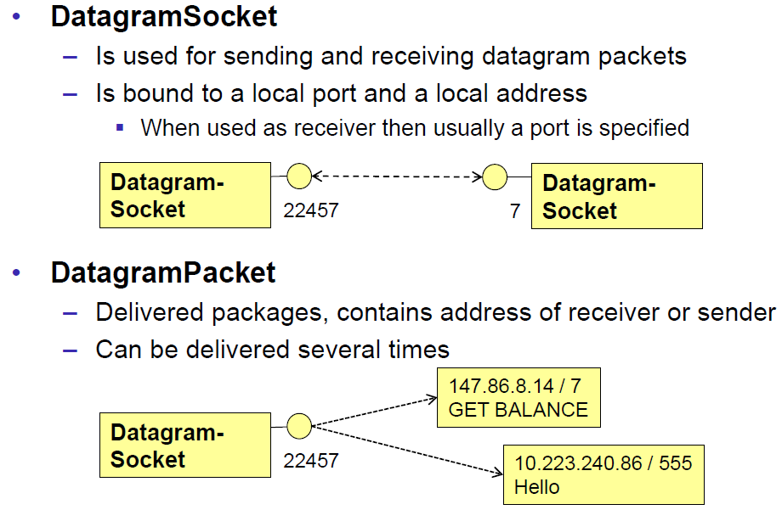

### DatagramSocket

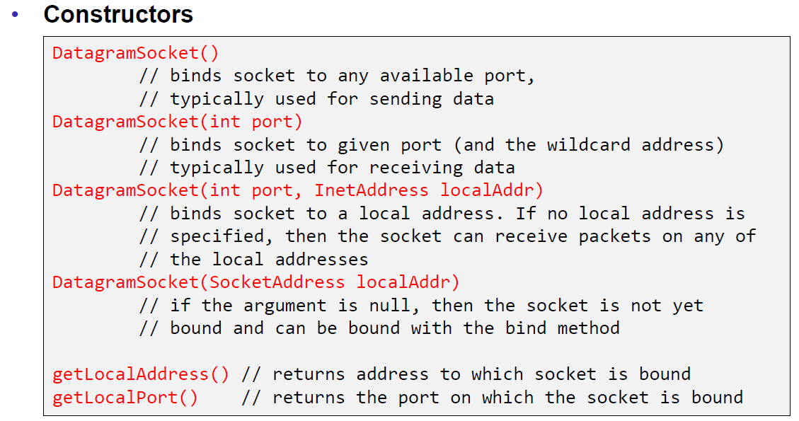

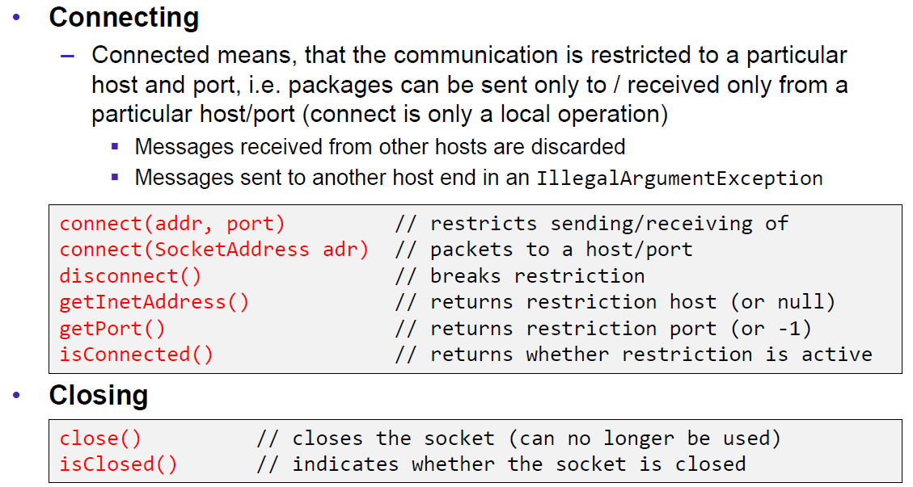

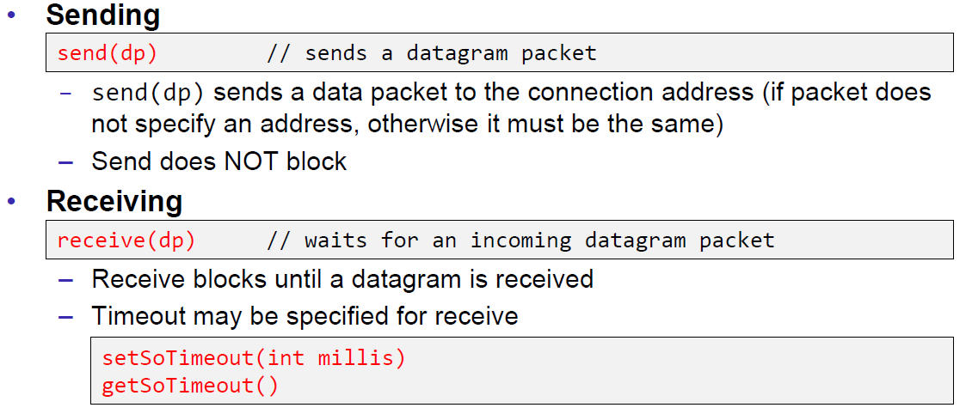

### DatagramPacket

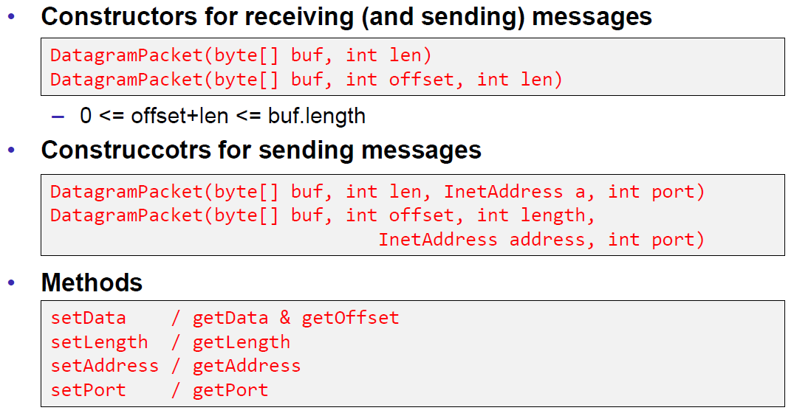

### Example of a UDP Server and Client

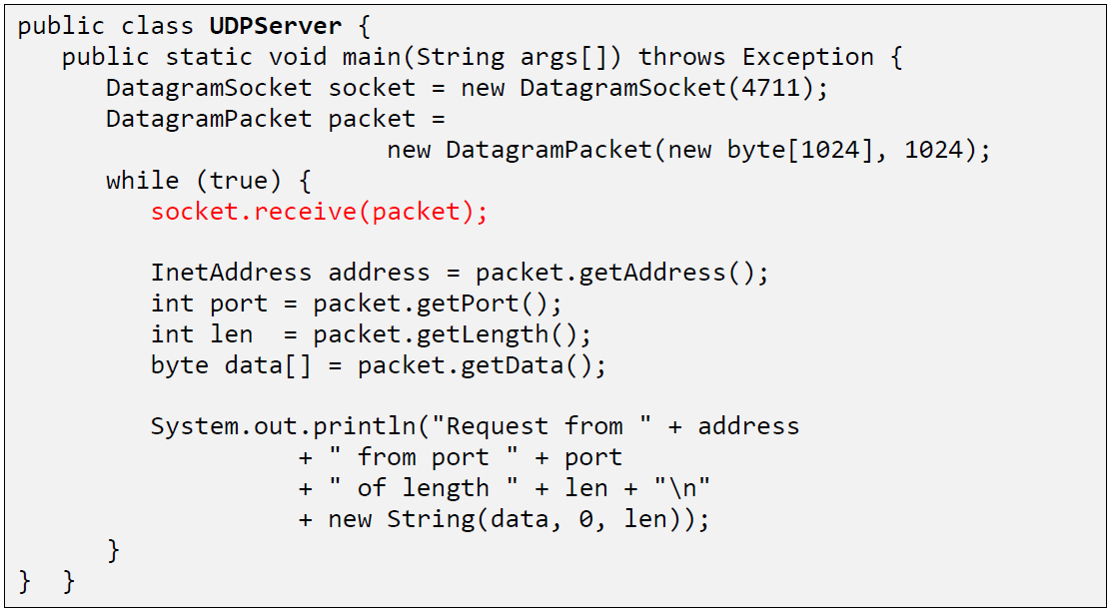

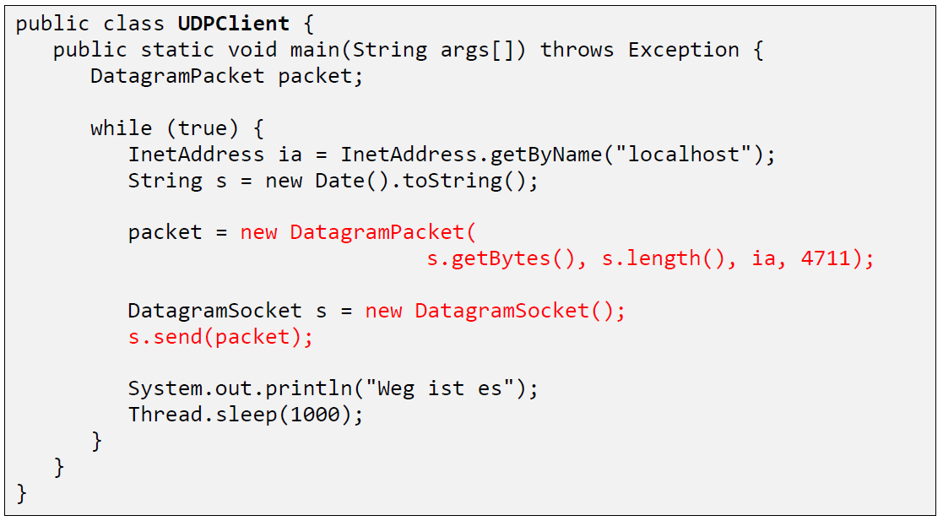

### UDP Implementation

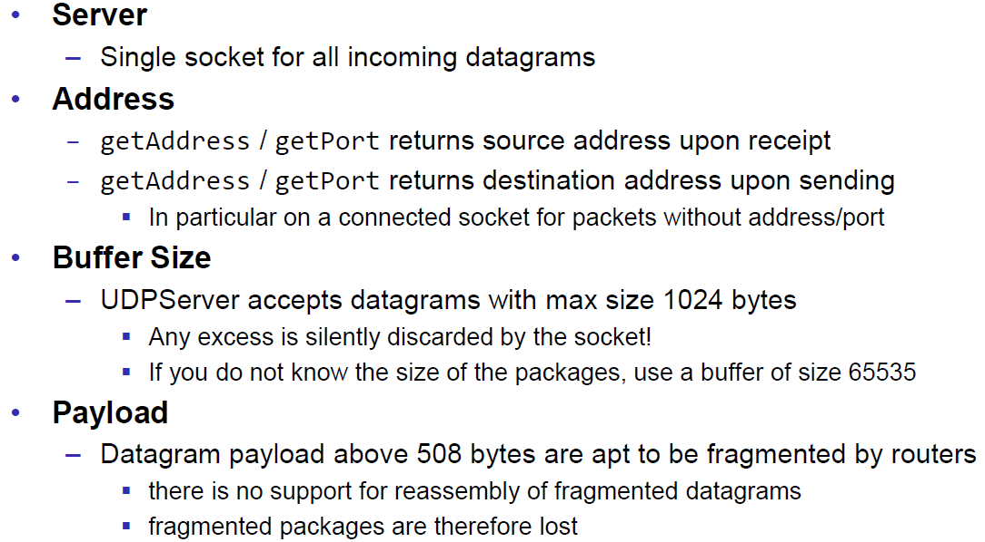

### Reliable UDP

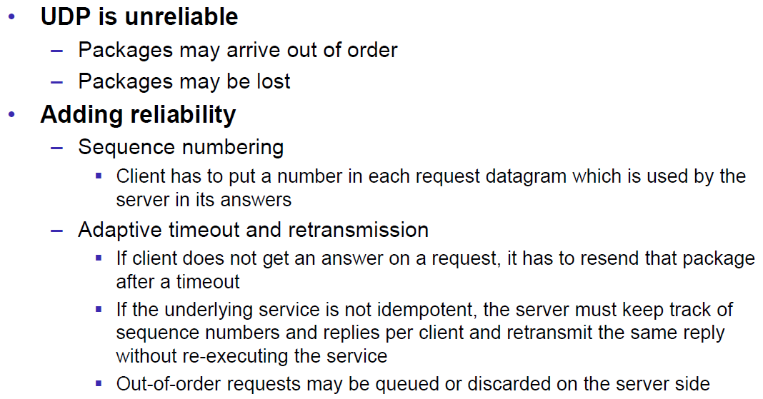

# Woche 3

## HTTP Protocol

### IETF RFC

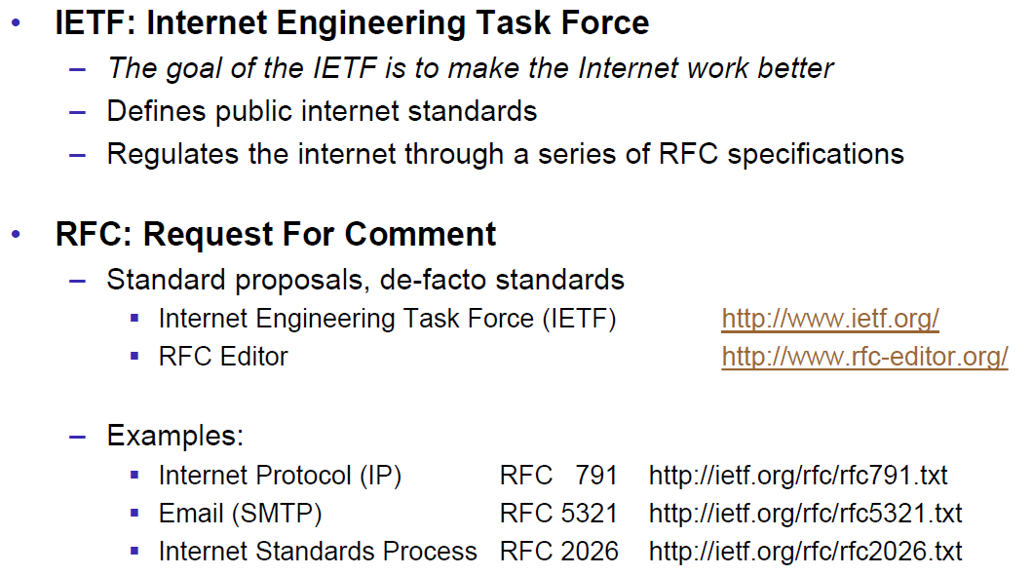

### HTTP Protocol

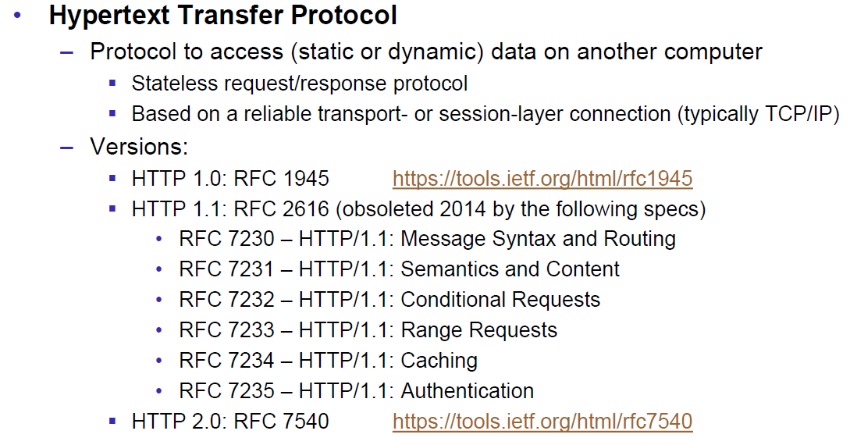

### HTTP Request

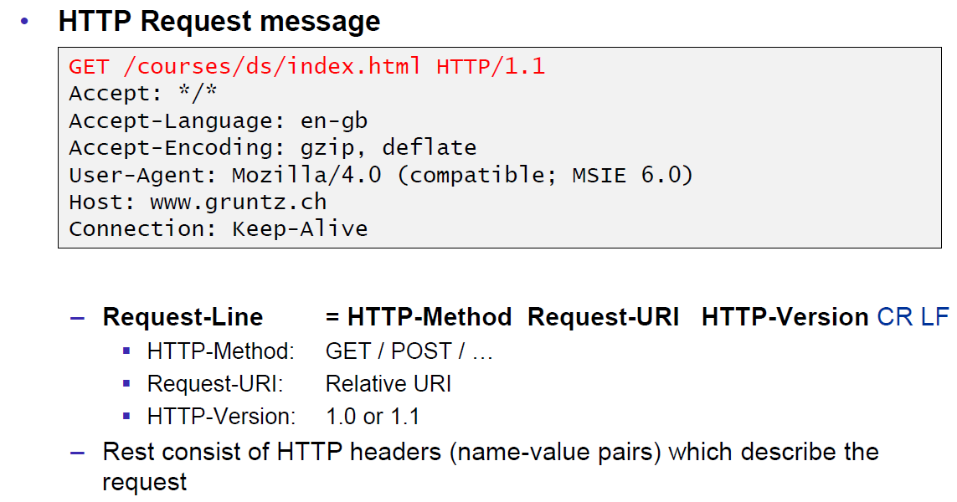

### HTTP Response

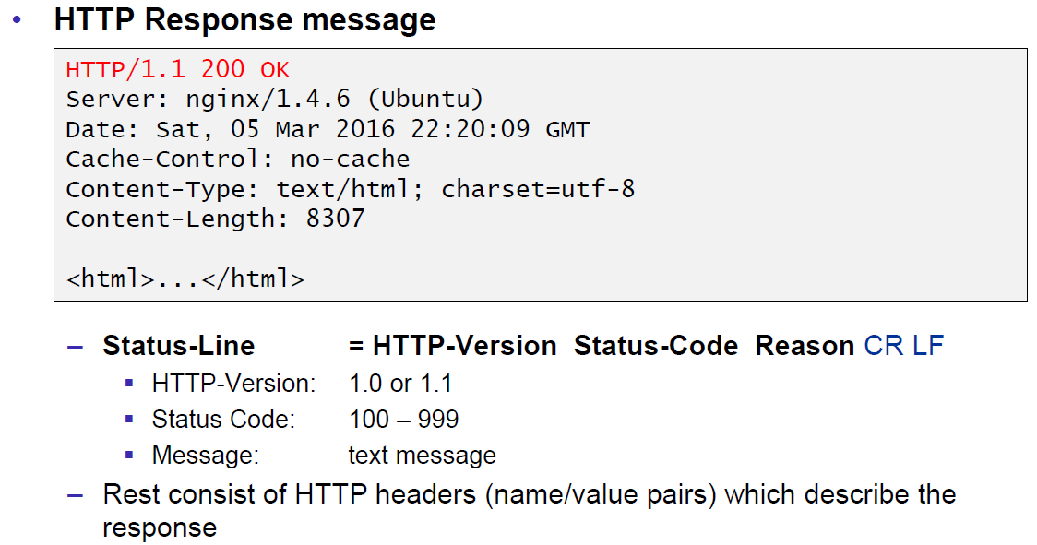

### HTTP Protocol

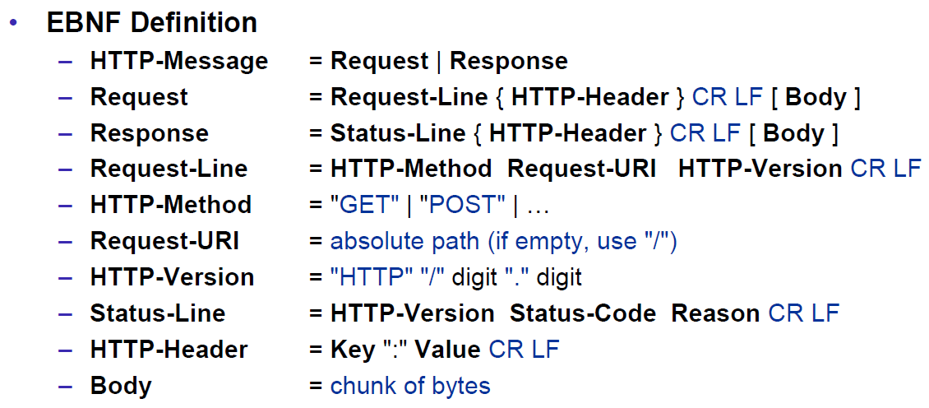

### HTTP Sample

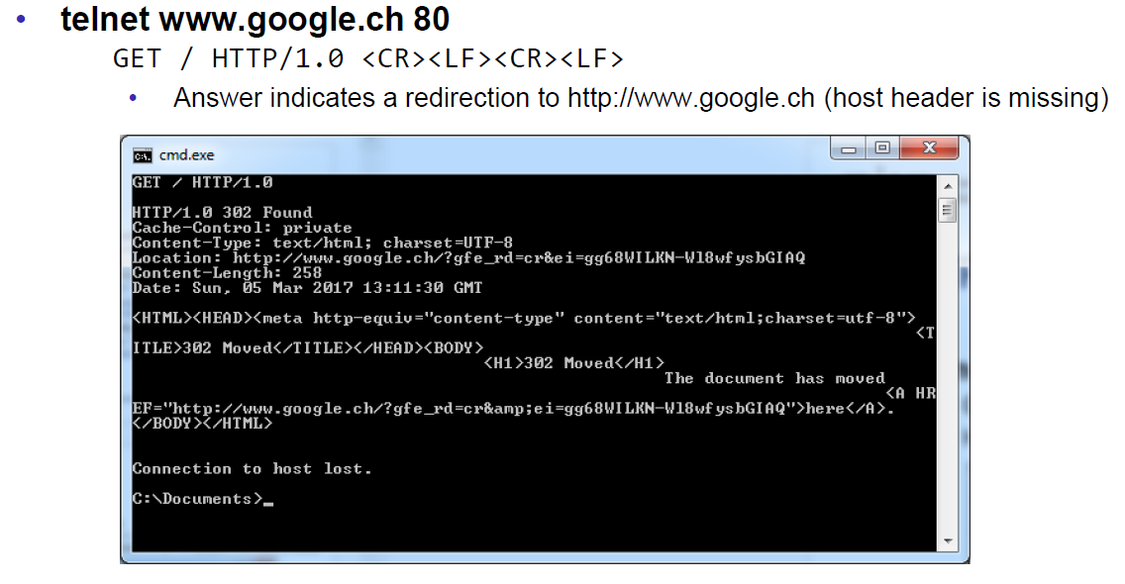

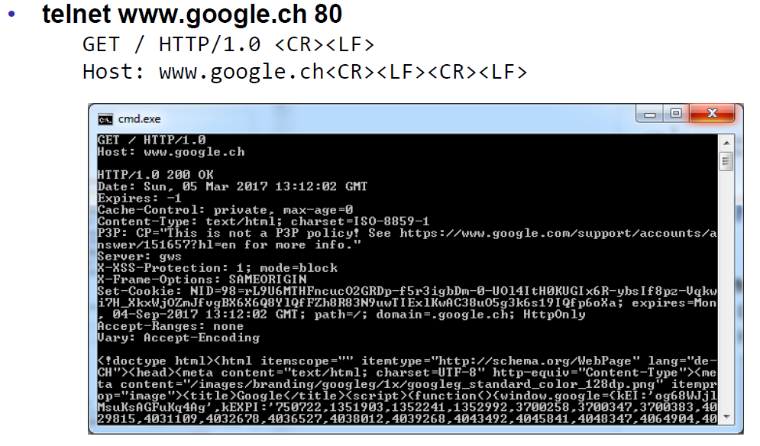

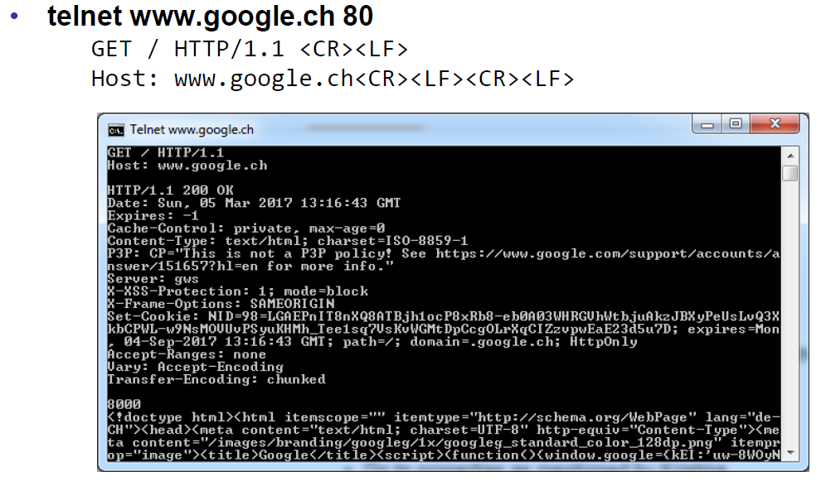

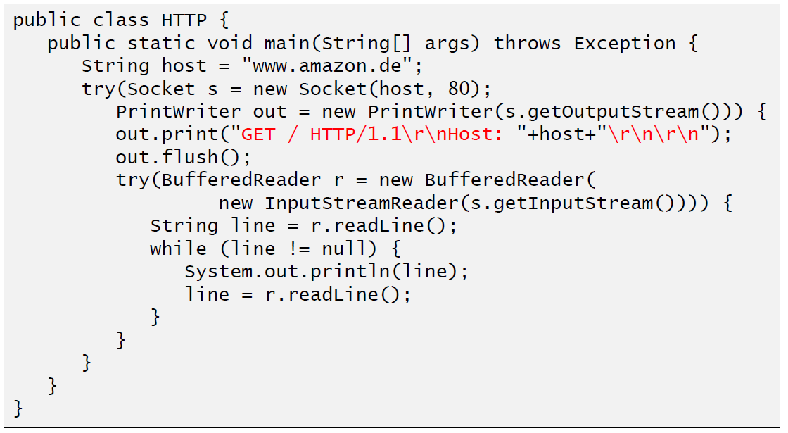

### HTTP 1.0 Request Methods

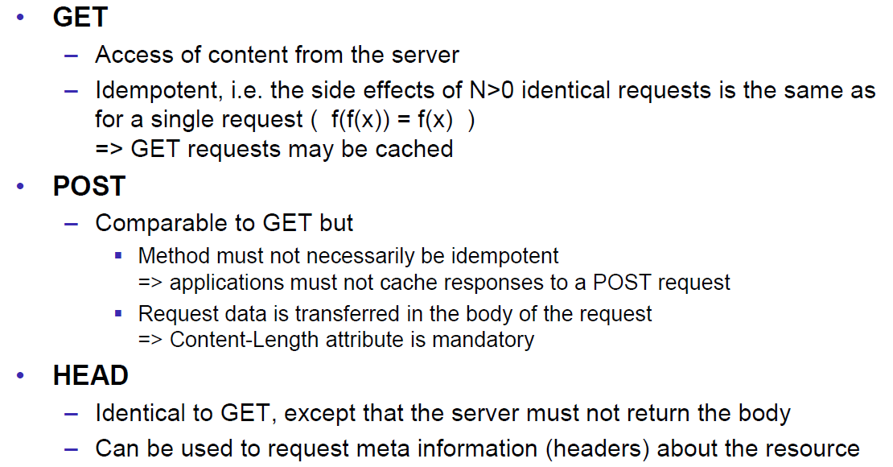

### HTTP Response Codes

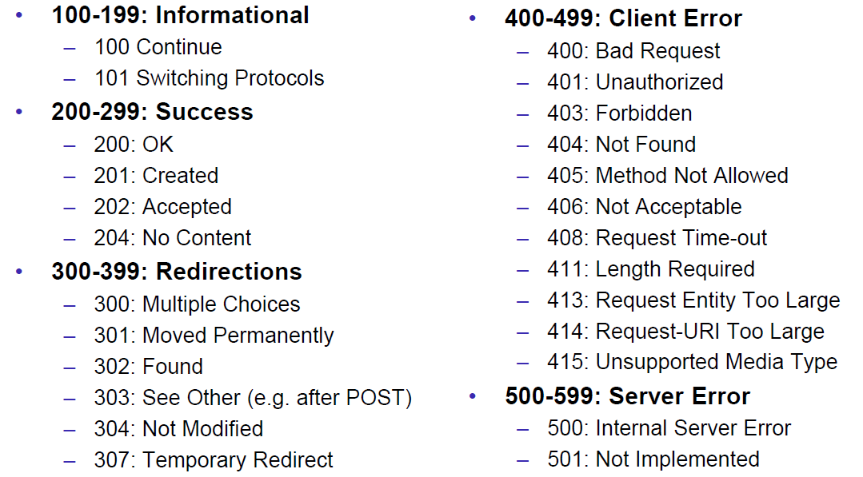

### HTTP Request Headers

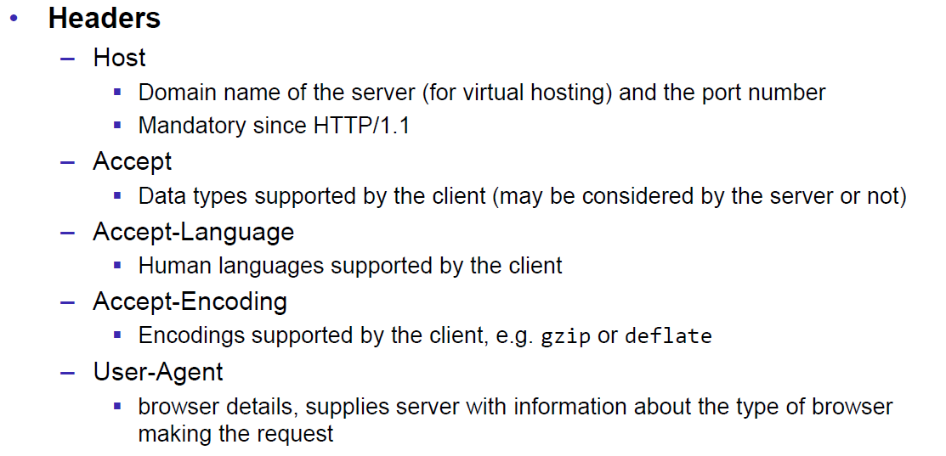

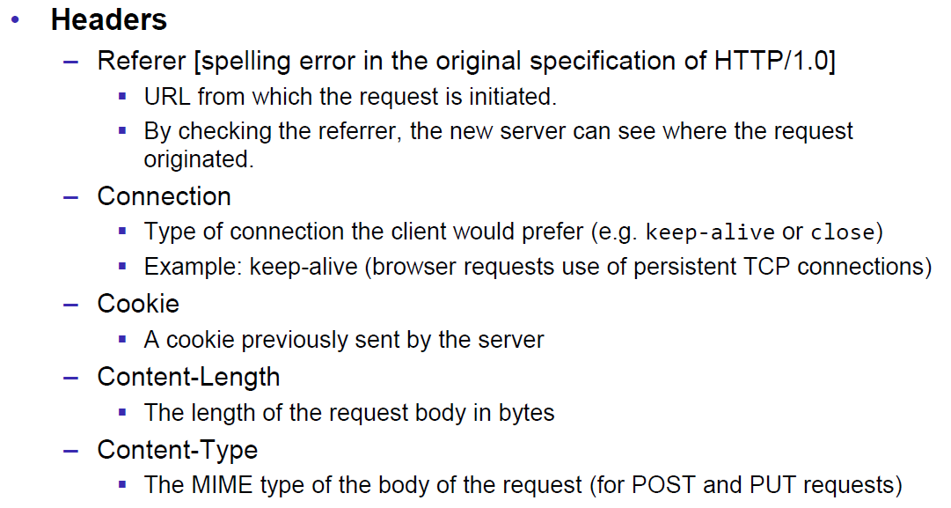

### HTTP Response Headers

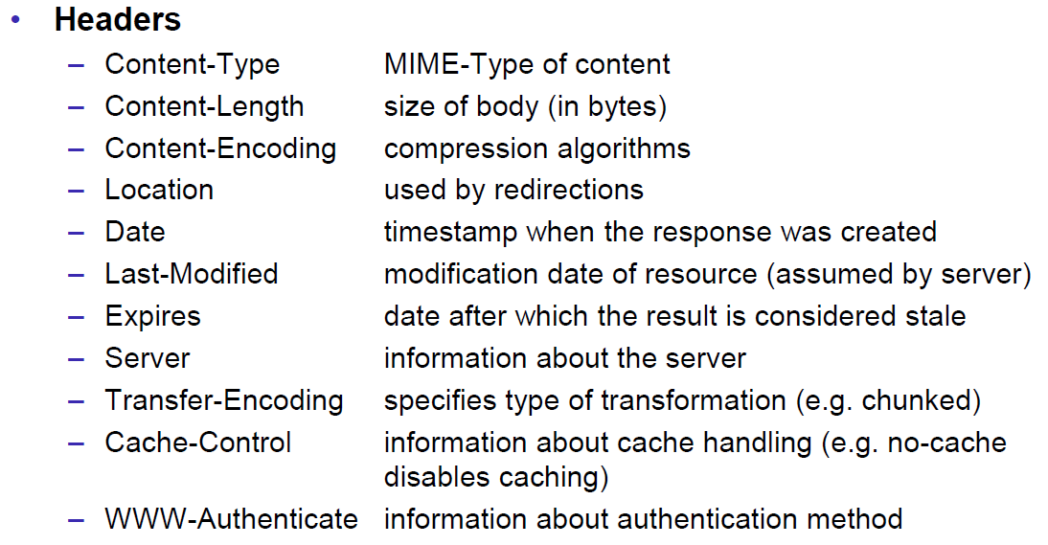

### MIME Types

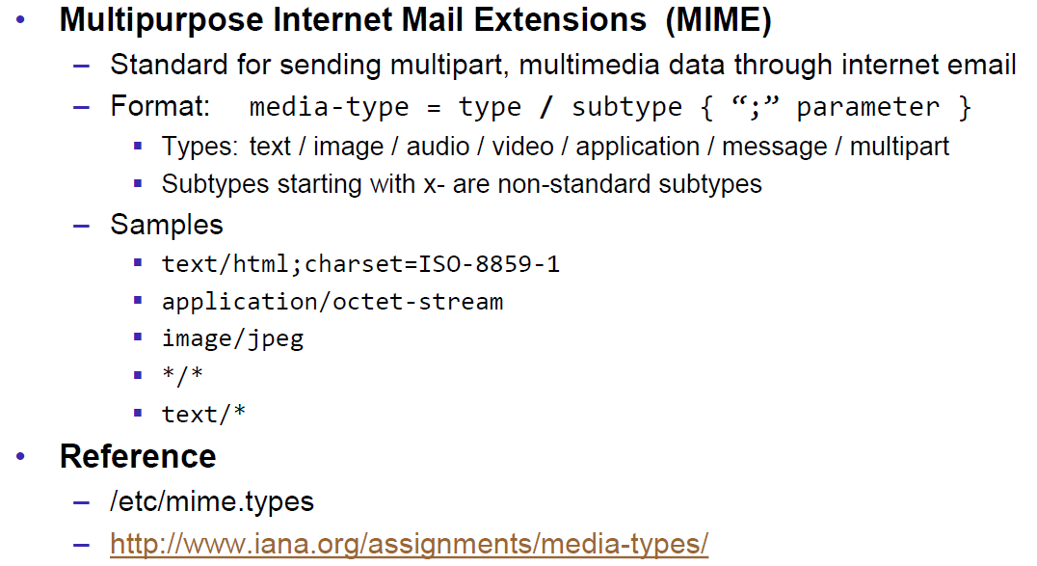

### HTTP Request/Response Sample

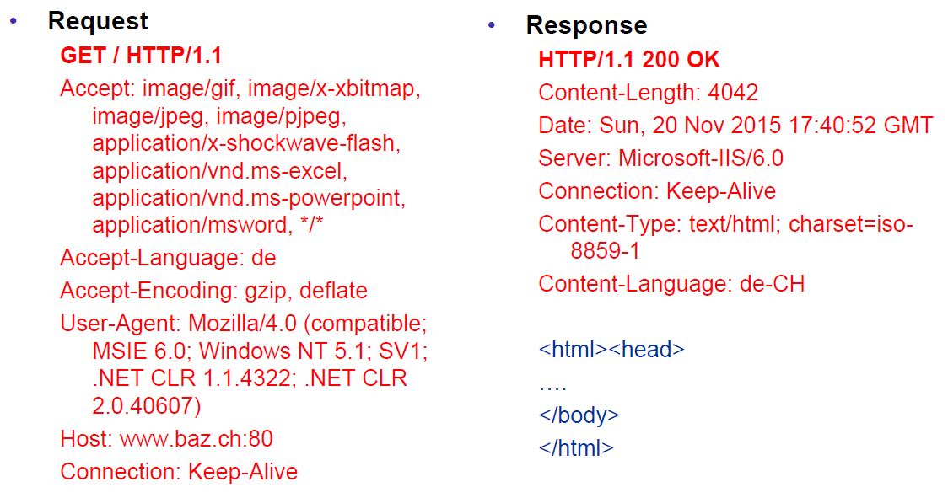

### HTTP 1.1 Enhancements

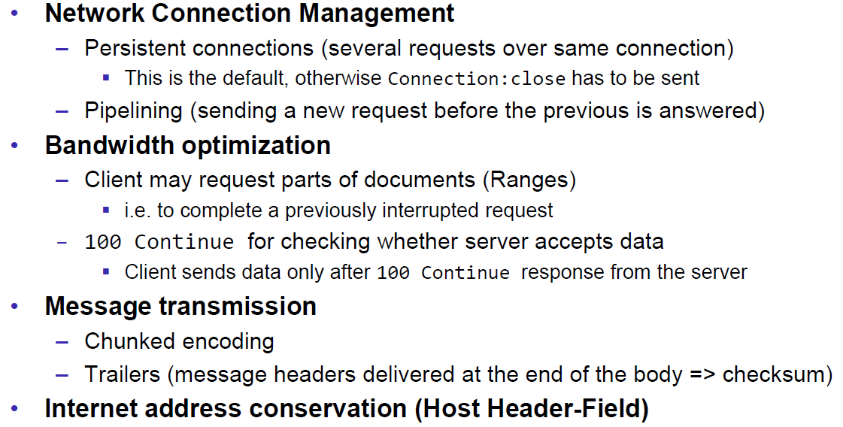

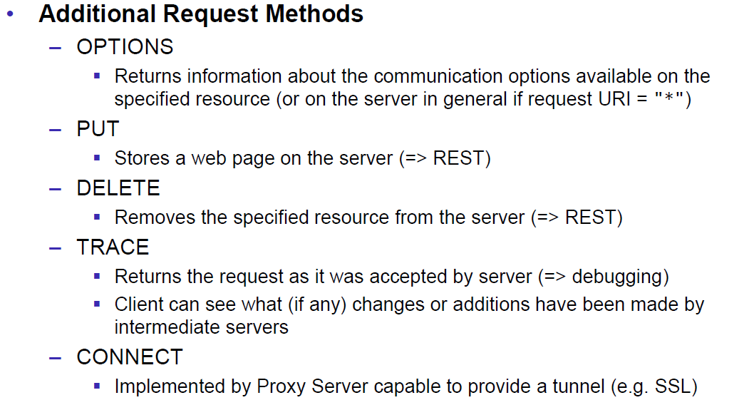

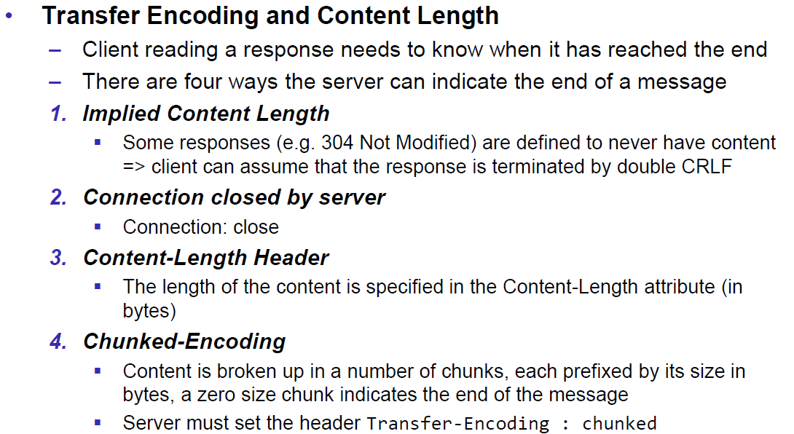

## HTTP Web Server

### A simple Web Server

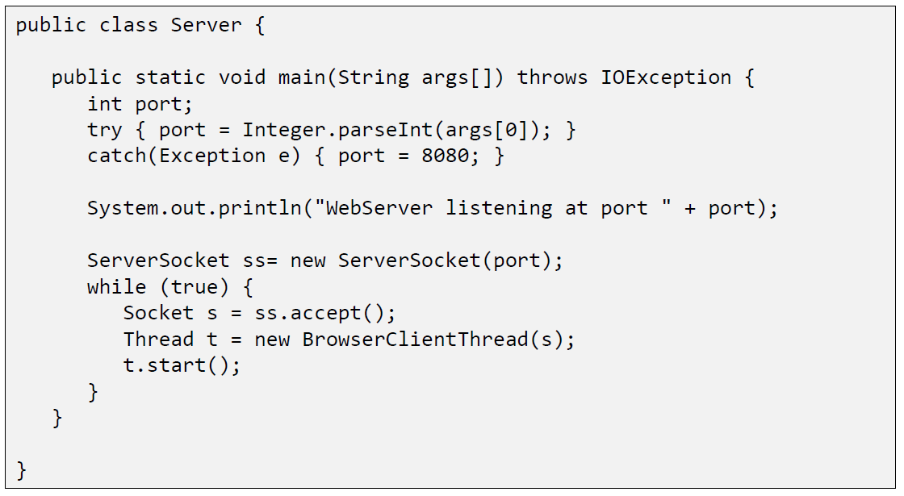

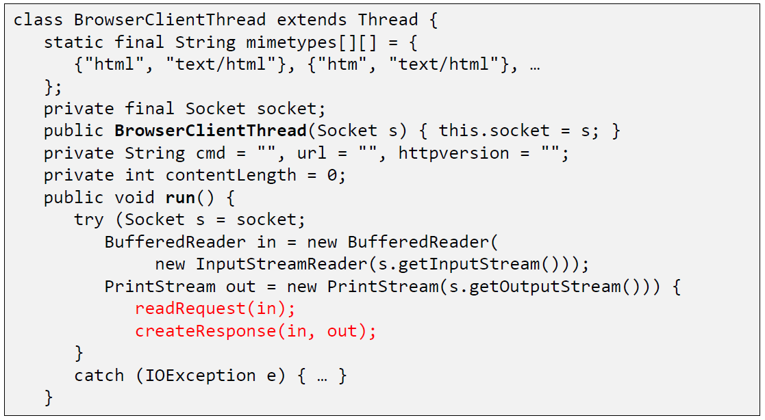

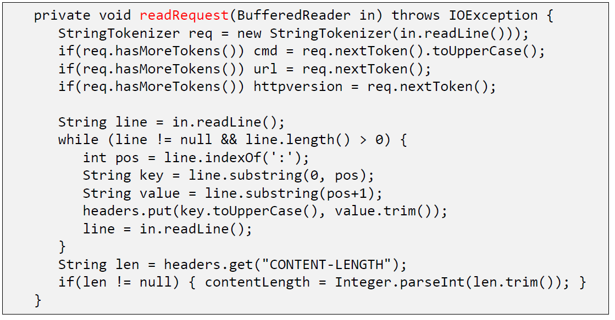

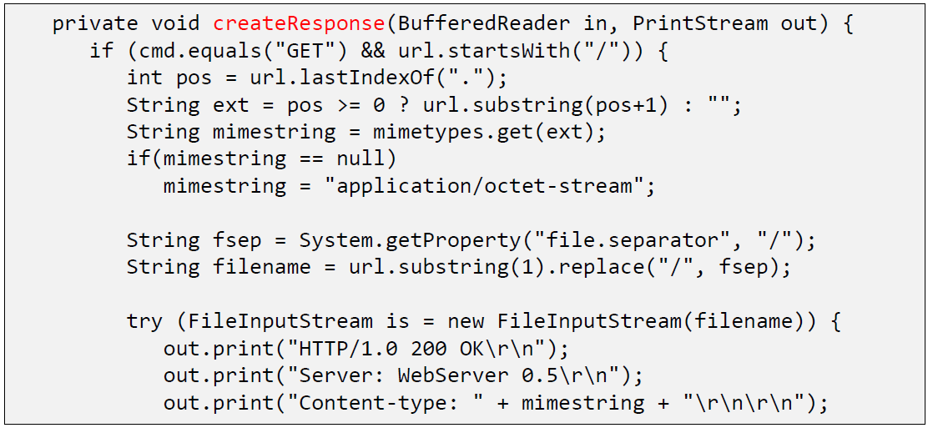

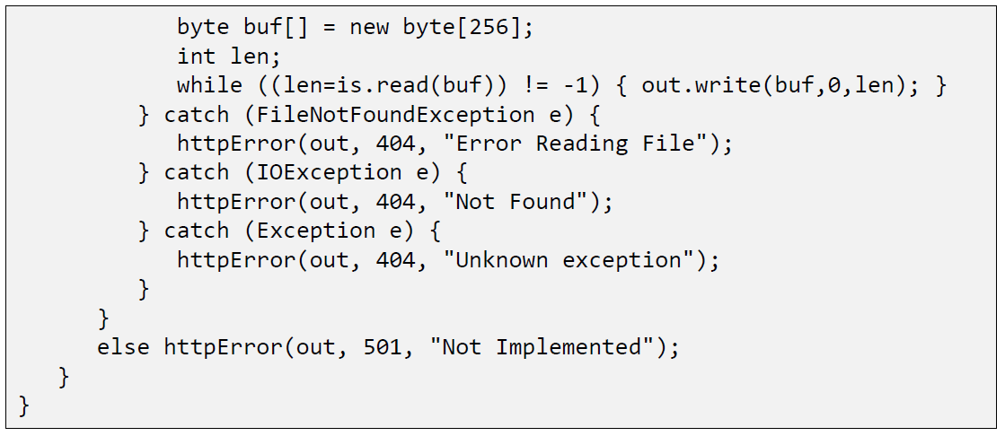

### Java internal Web Server

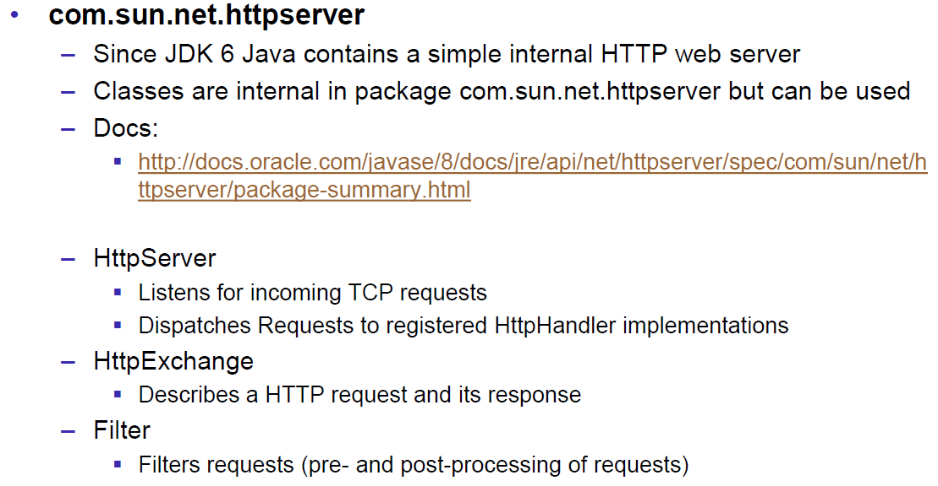

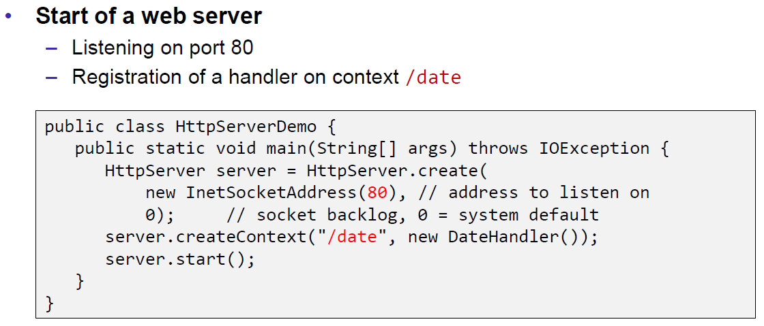

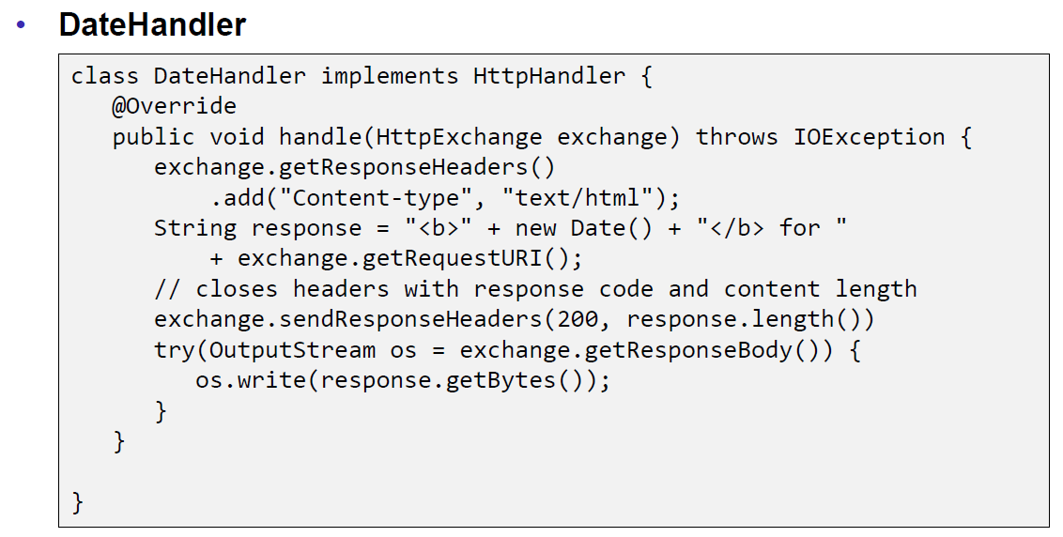

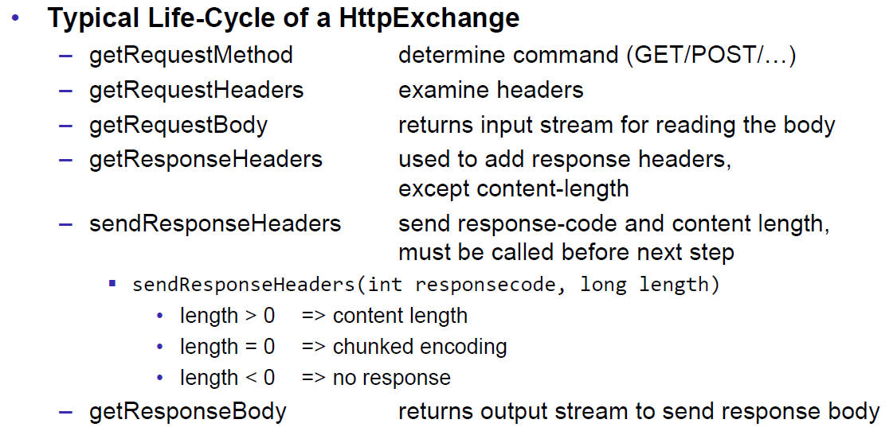

## HTML Forms & URL Encoding

### HTML GET Form

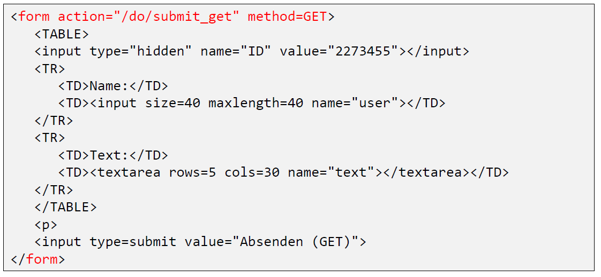

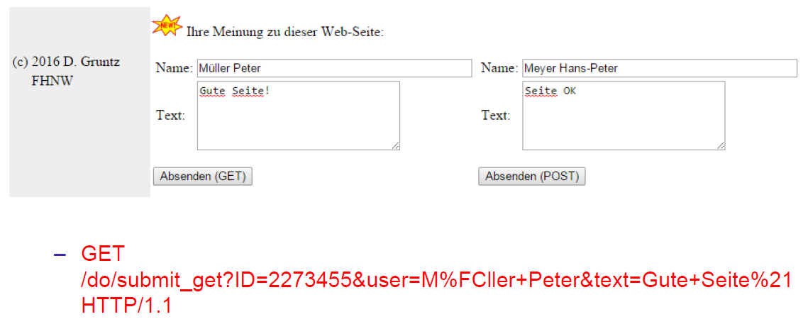

### URL Encoding

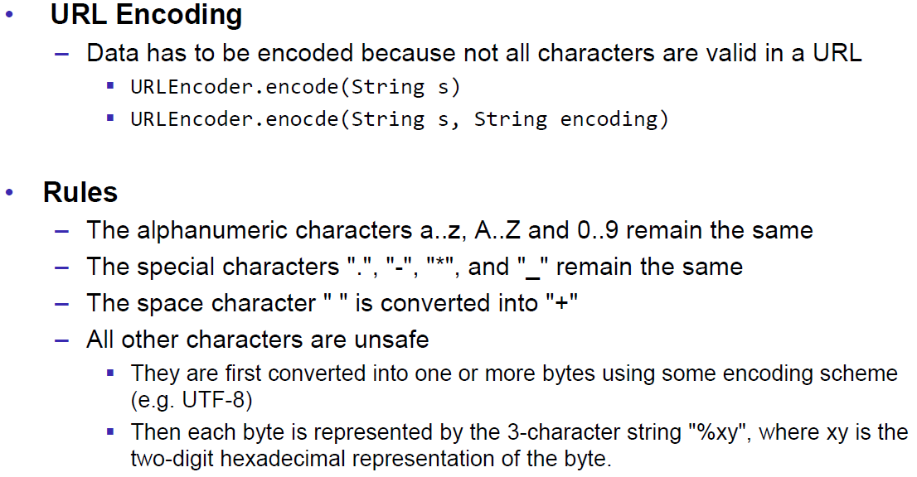

### HTML POST Form

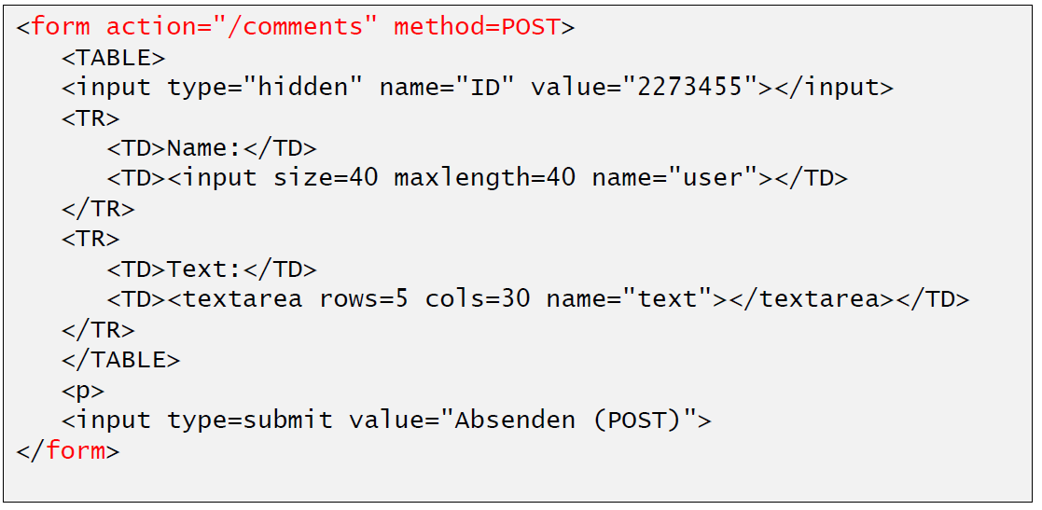

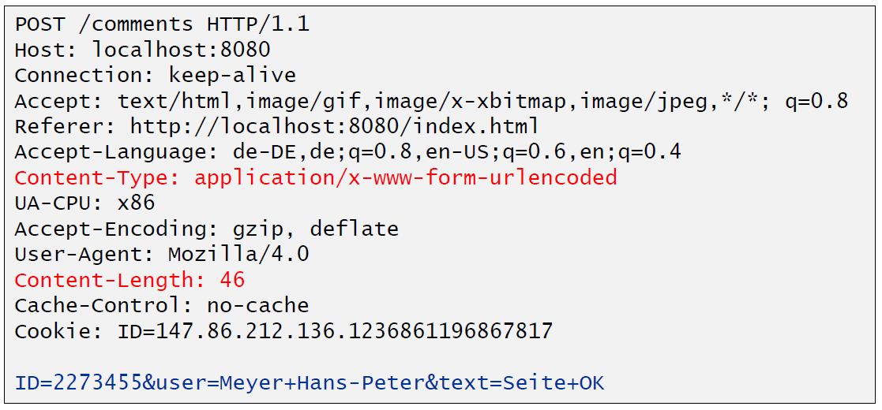

## HTTP Requests from Java

### URL

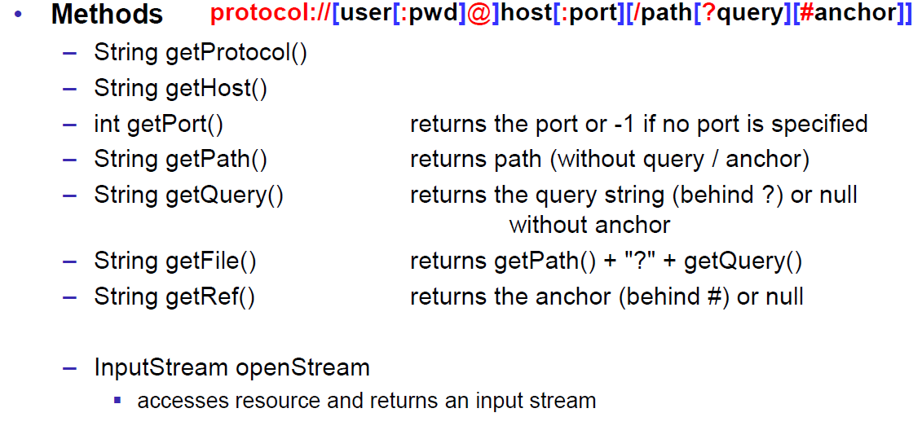

### Sending GET Requests from within Java

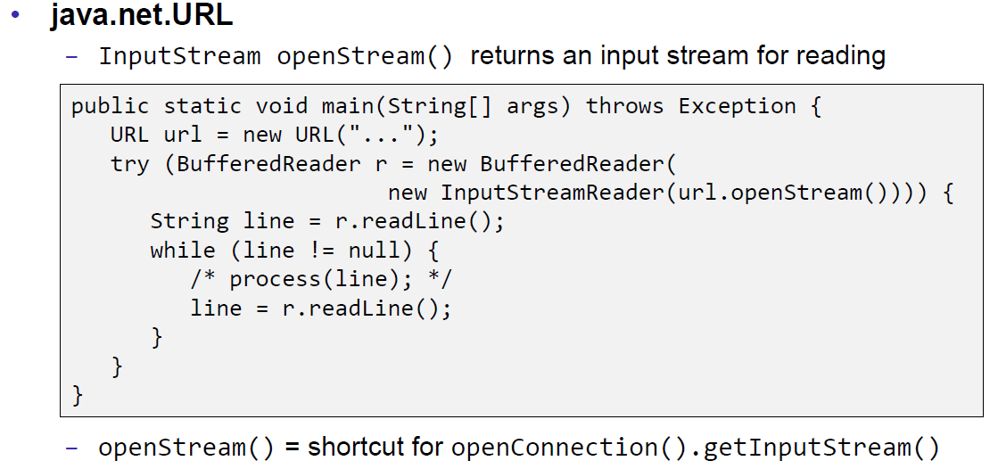

### URLConnection

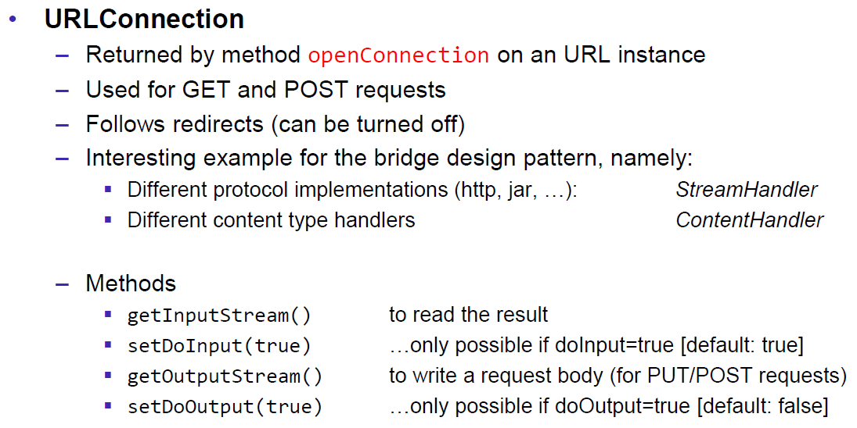

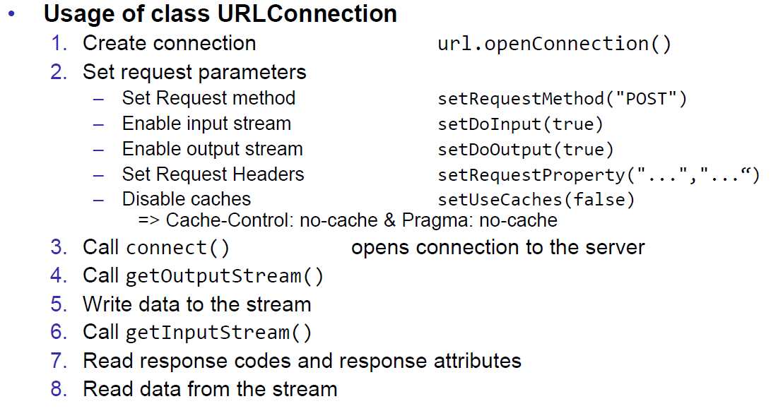

### URLConnection Tips & Tricks

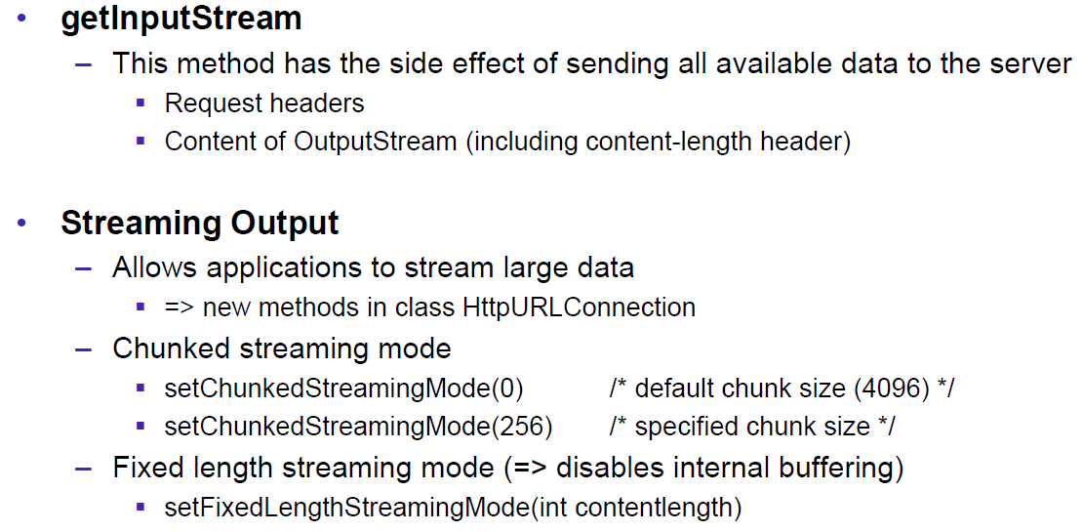

### Sample 1: URLConnection GET

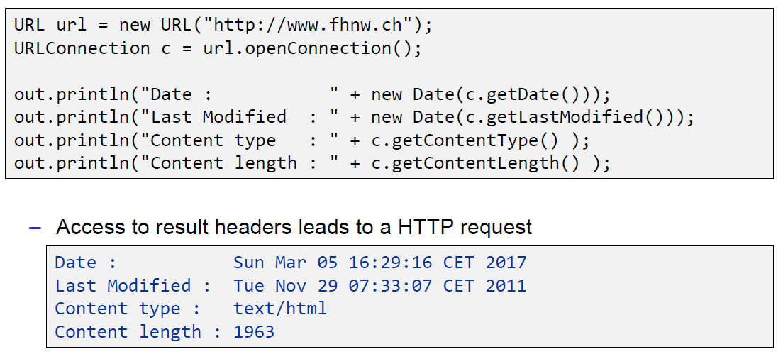

### Sample 2: URLConnection POST

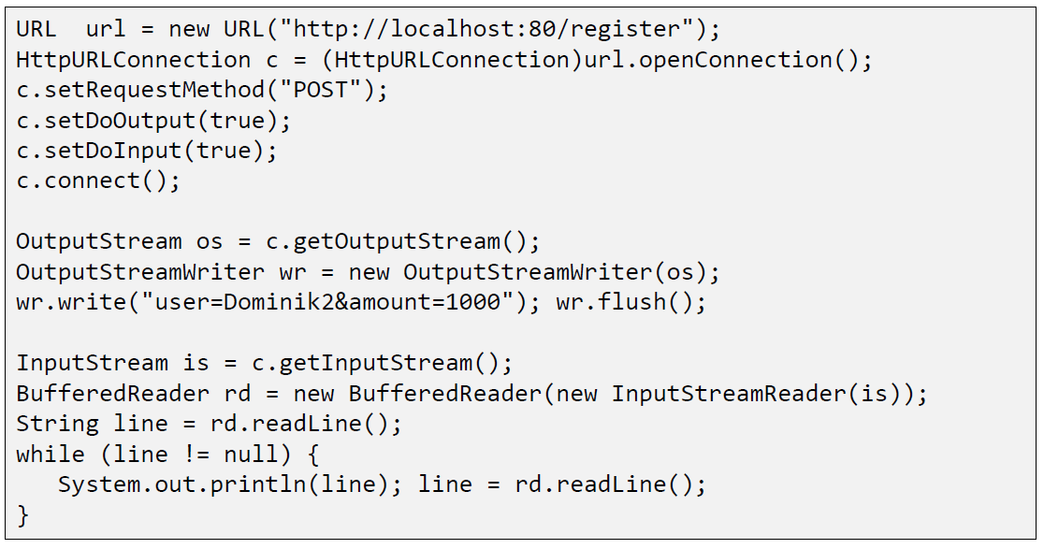

### Sample 3: Currency Converter

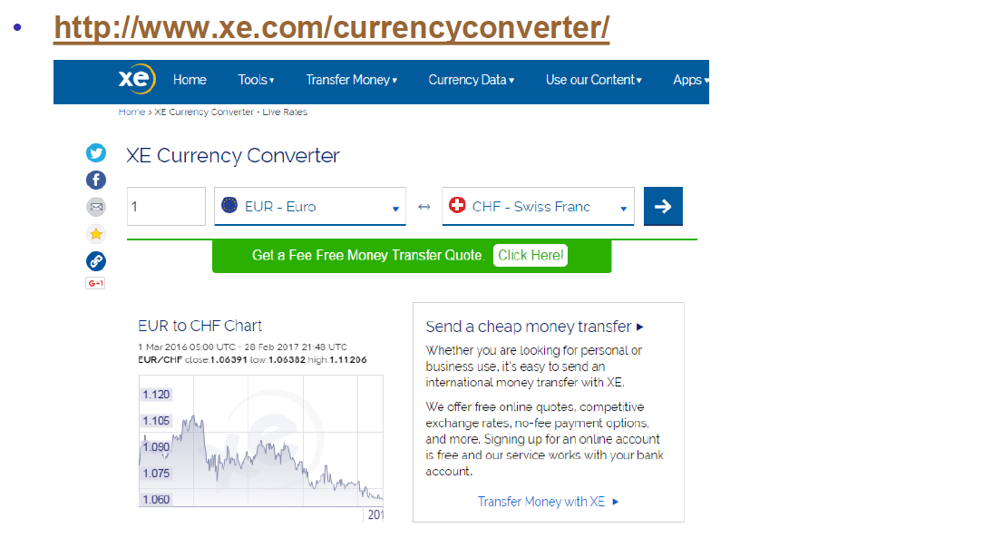

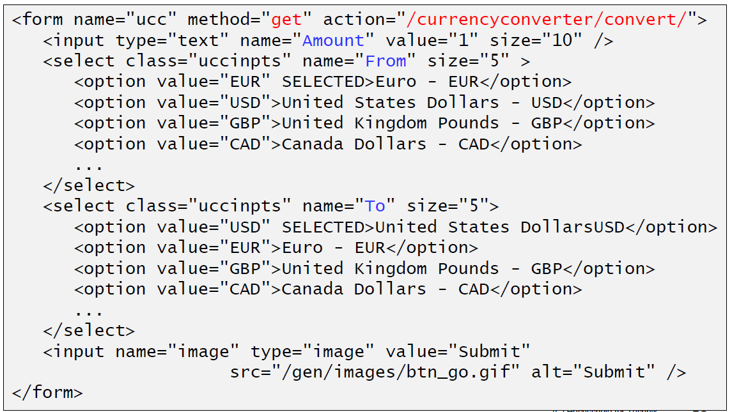

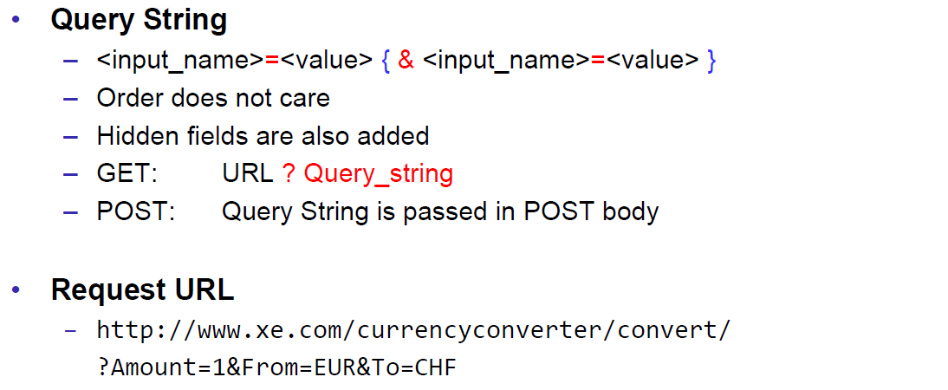

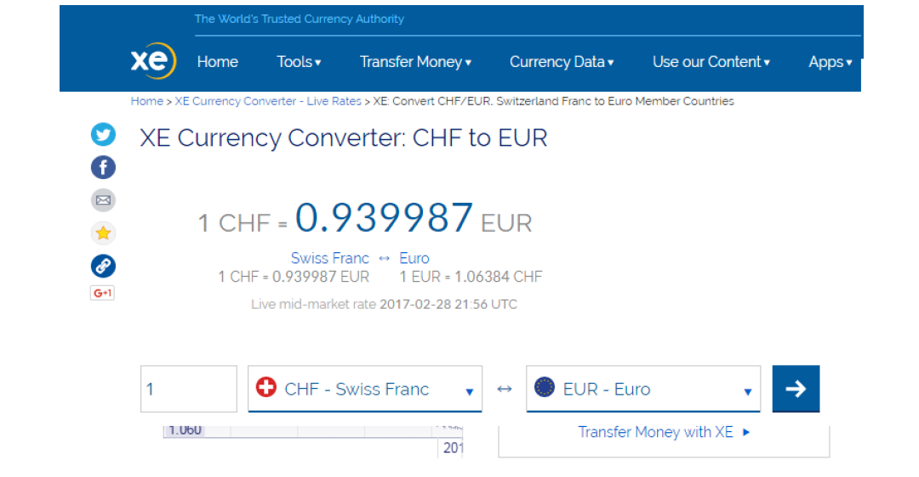

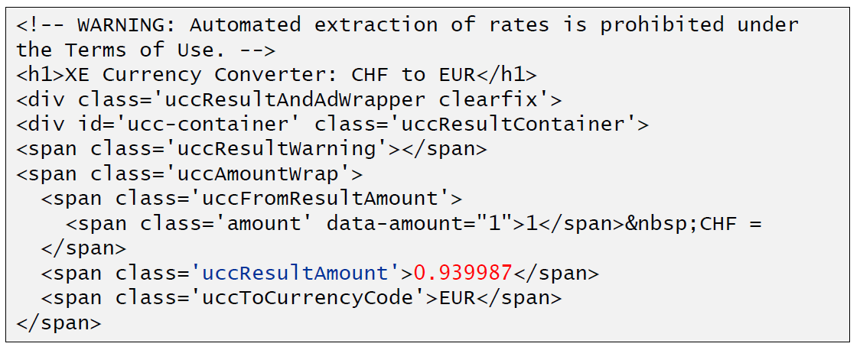

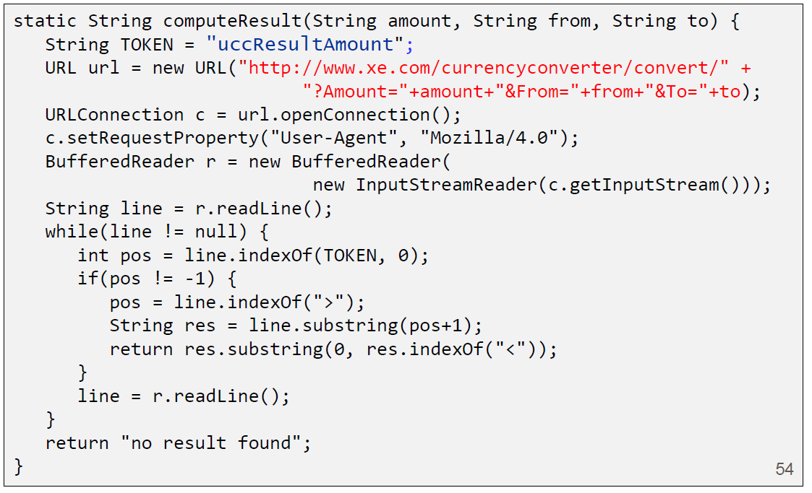

### Other Libraries

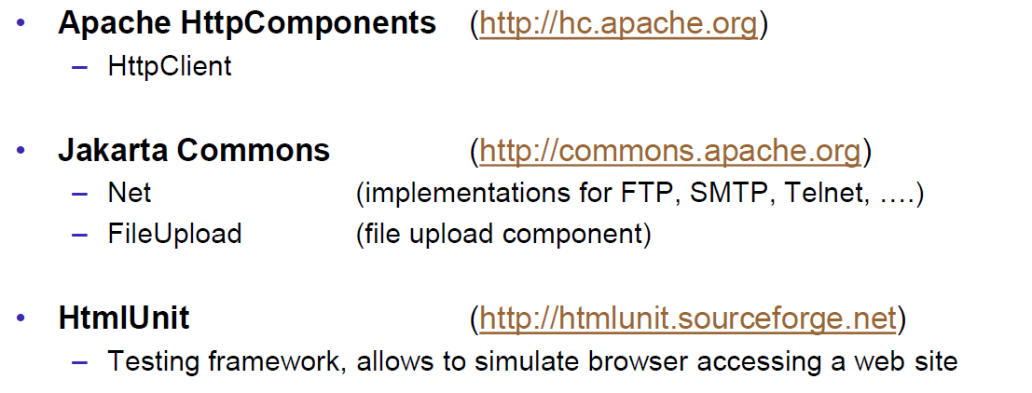

# Woche 4